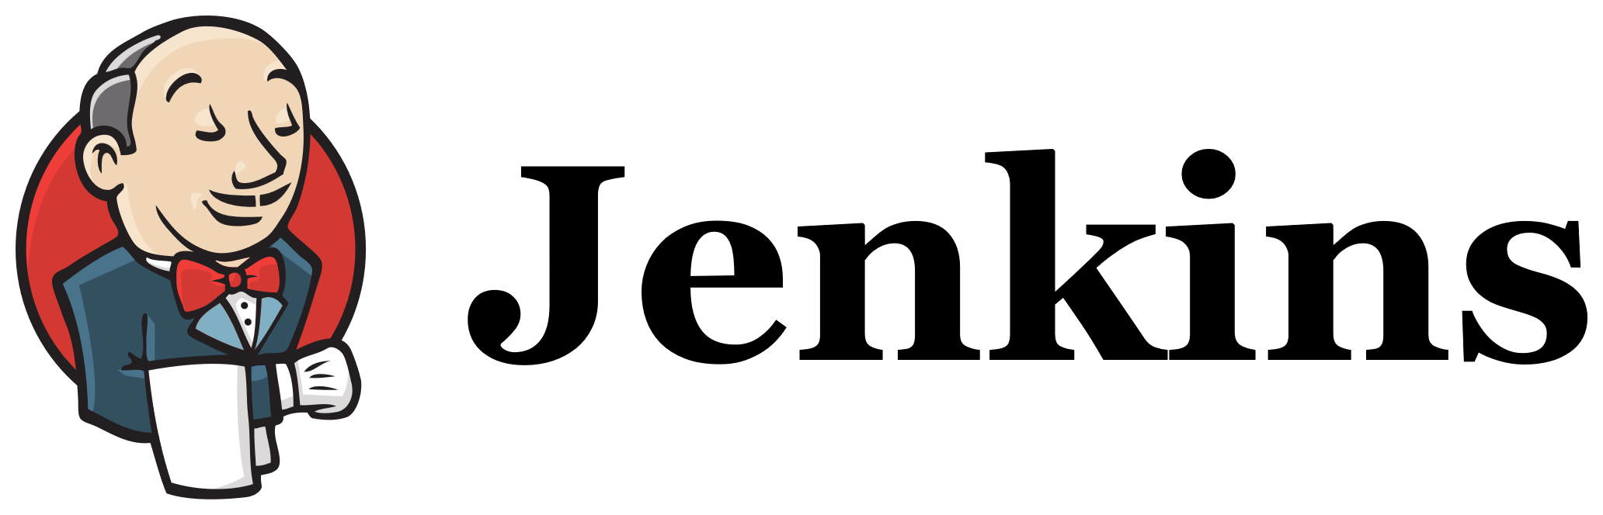
Task Title:
Install Jenkins and run Jenkins on port number 8081.
Objective:
Installing JENKINS and changing the port number 8080 -->8081
Prerequisites:
- EC2 instance with 15-20 gb of Volume
- Java Package of version 17
- JENKINS package
Step by Step Implementation:
Step 1: Launch an EC2 Instance with required Configurations
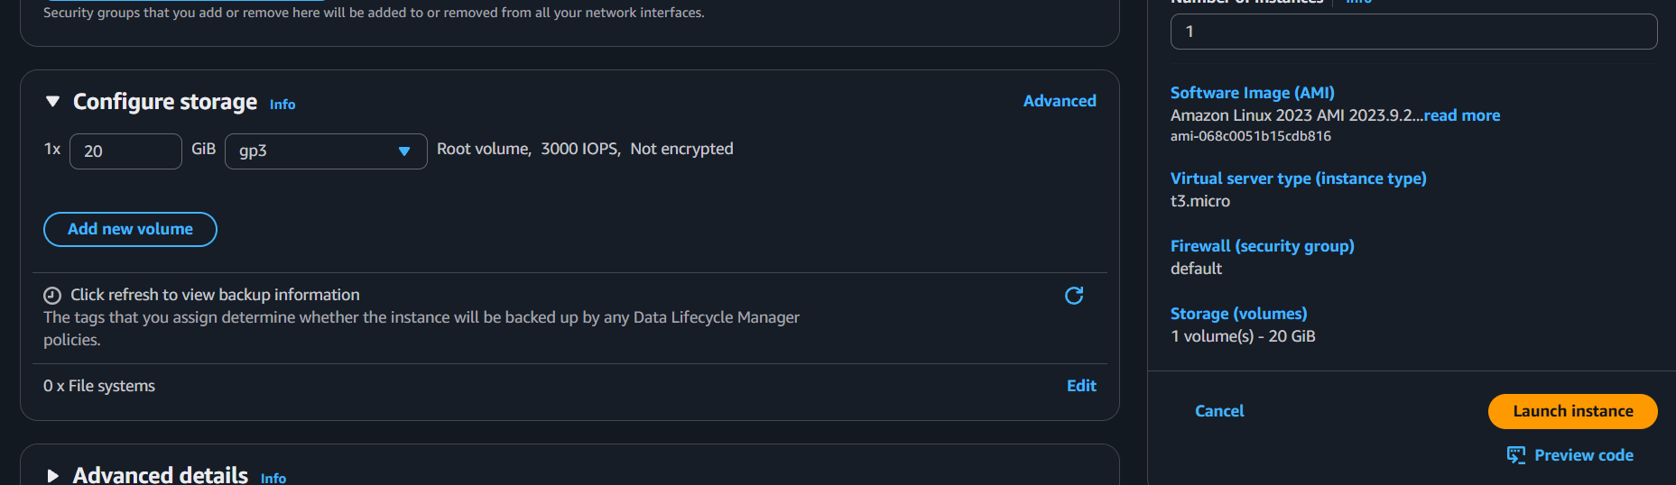
Step 2: Connect the ec2 using git bash
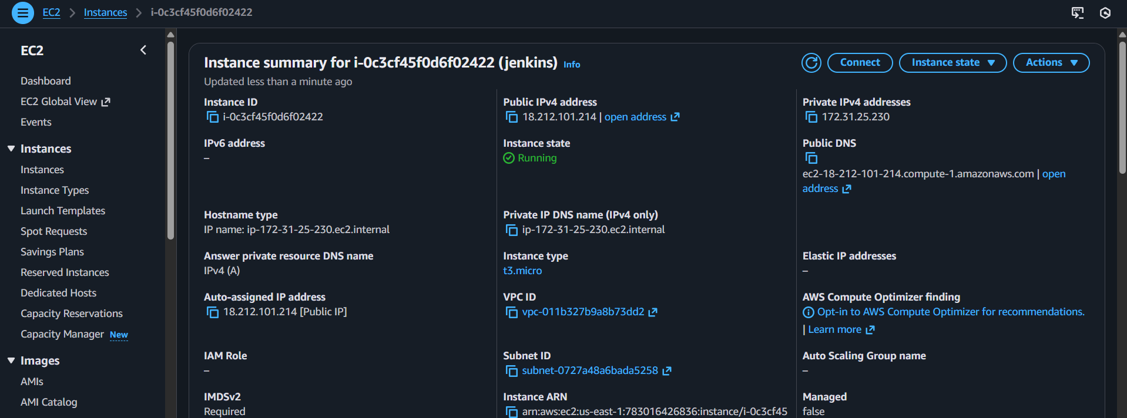

Step 3: Connected In git bash and updated the dependencies
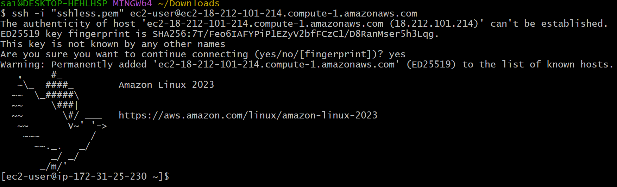
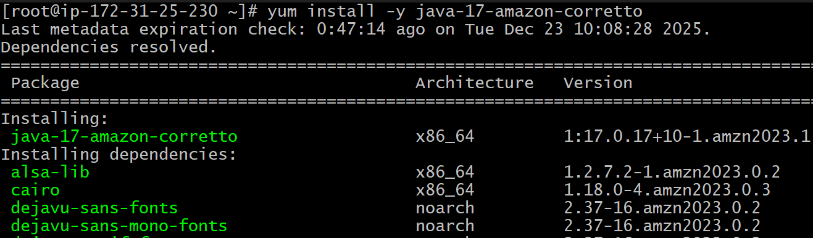
Step 4: Install java version of 17 in ec2

Step 5: Use the Link to download the Jenkins package and rpm keys
Download jenkins Repo:
=====================
sudo wget -O /etc/yum.repos.d/jenkins.repo https://pkg.jenkins.io/redhat-stable/jenkins.repo
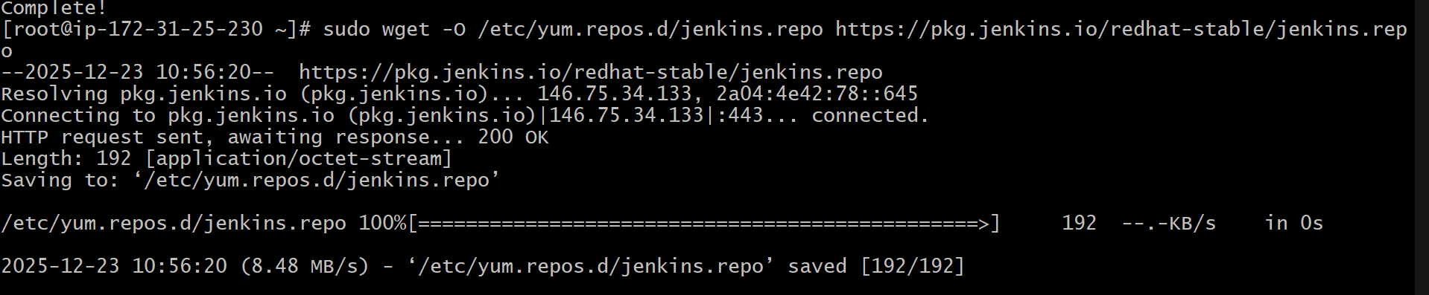

Import the jenkins key:
======================
sudo rpm --import https://pkg.jenkins.io/redhat-stable/jenkins.io-2023.key
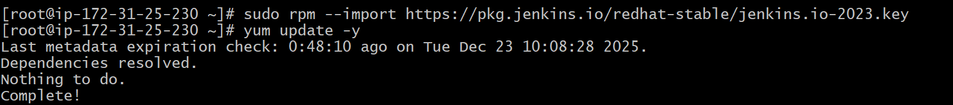
Step 6: Use the Command to Install Jenkins.
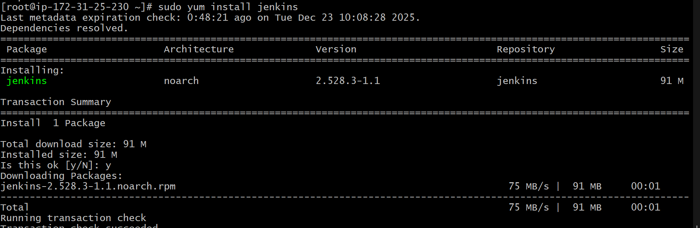
And start the service and check the status in cli and GUI
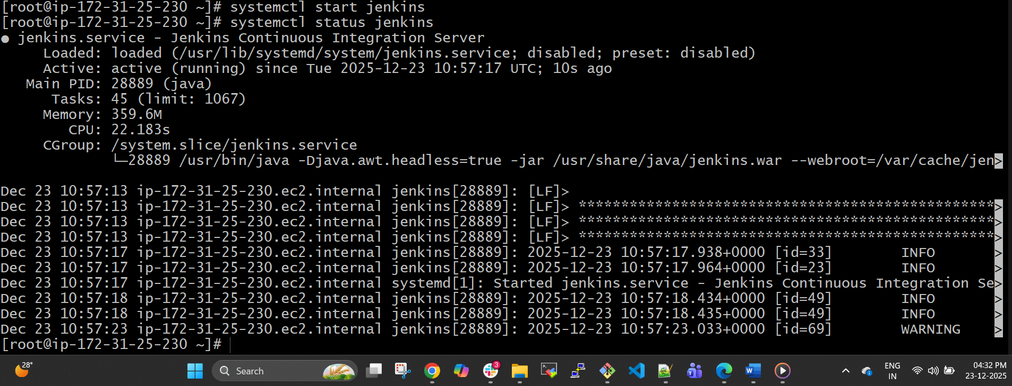

Using Publicip:8080 Default port number of Jenkins
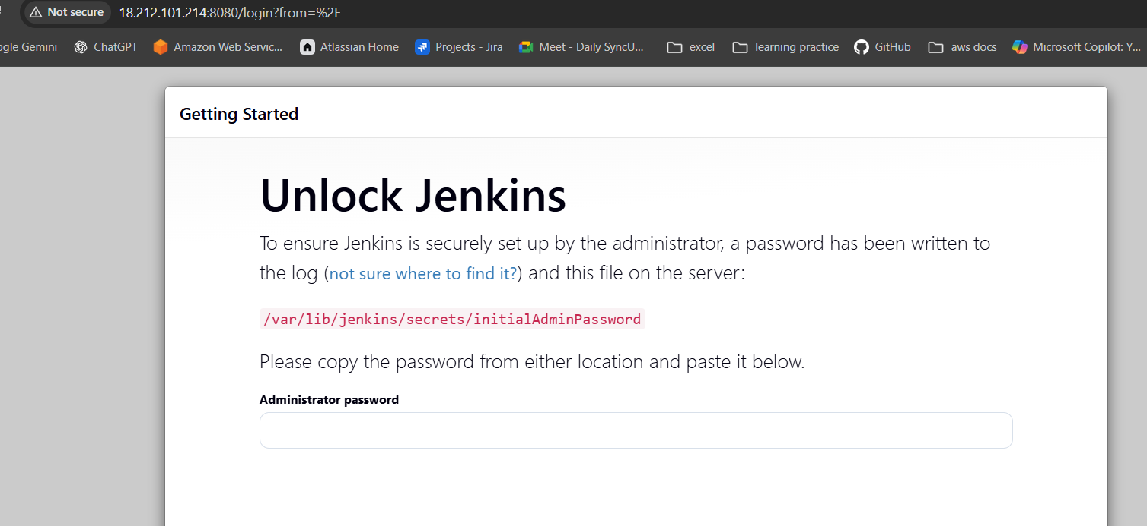
Step 7: Default Deployment Location of Jenkins is /var/lib/Jenkins/
Change the directory to secrets/ and cat the initialadminpassword and copy the password and paste it over GUI
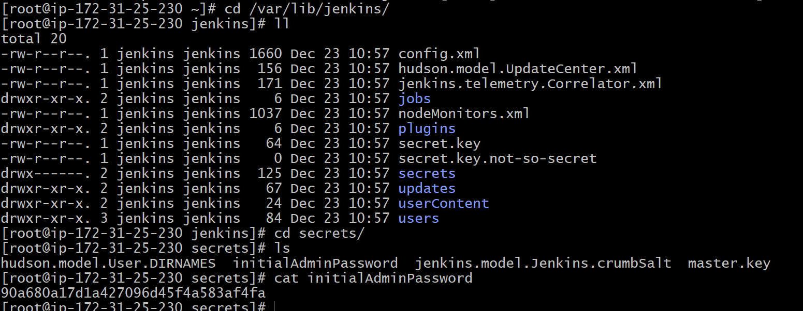

Paste the password to login
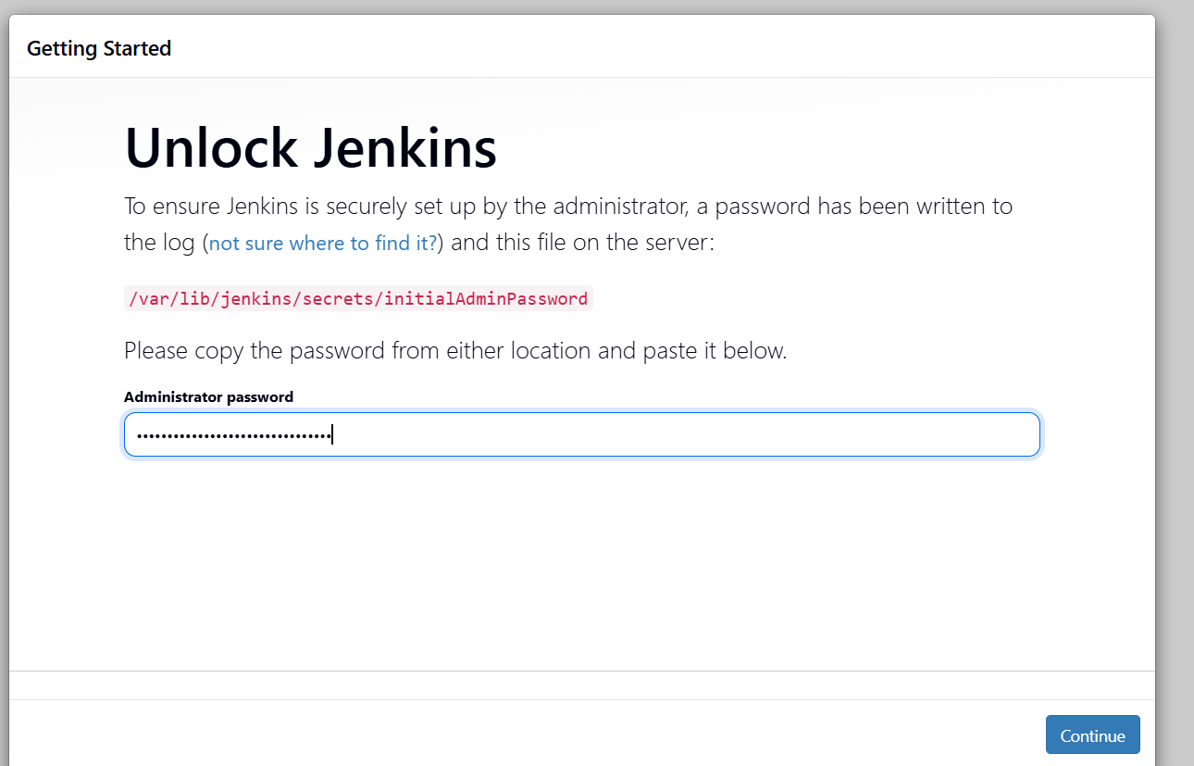
Step 8:
FOR CHANGING PORT NUMBER
Default location of file is /usr/lib/systemd/system/Jenkins.service
Use vi to access the file and change the port number 8080 to 8081
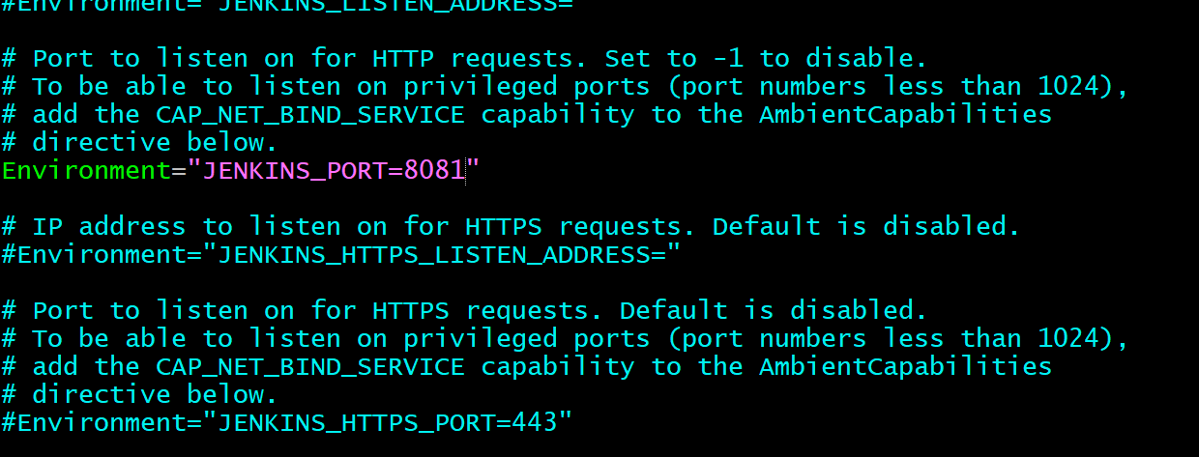

Step 9:
Before Changing the port number we had started the service so I got an issue that Jenkins is still running on port 8080 not on 8081 so that using the process id I killed the service and started again so that now Jenkins is running on PORT 8081
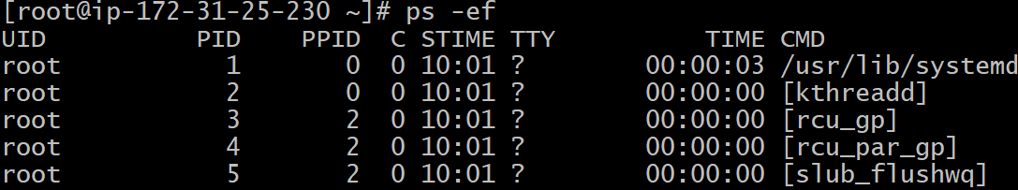
The process id of Jenkins was 28889 and using kill -9 PID command killed the process
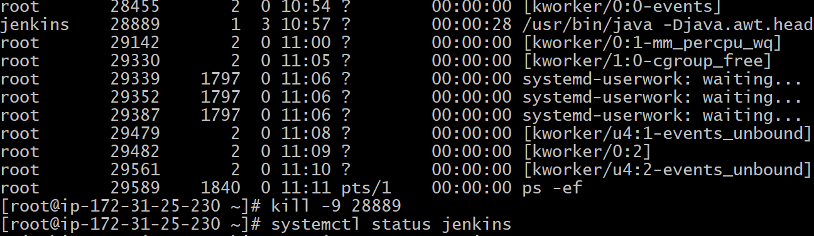
Step 10: After that do the daemon-reload and start and enable the Jenkins service
On PORT 8081
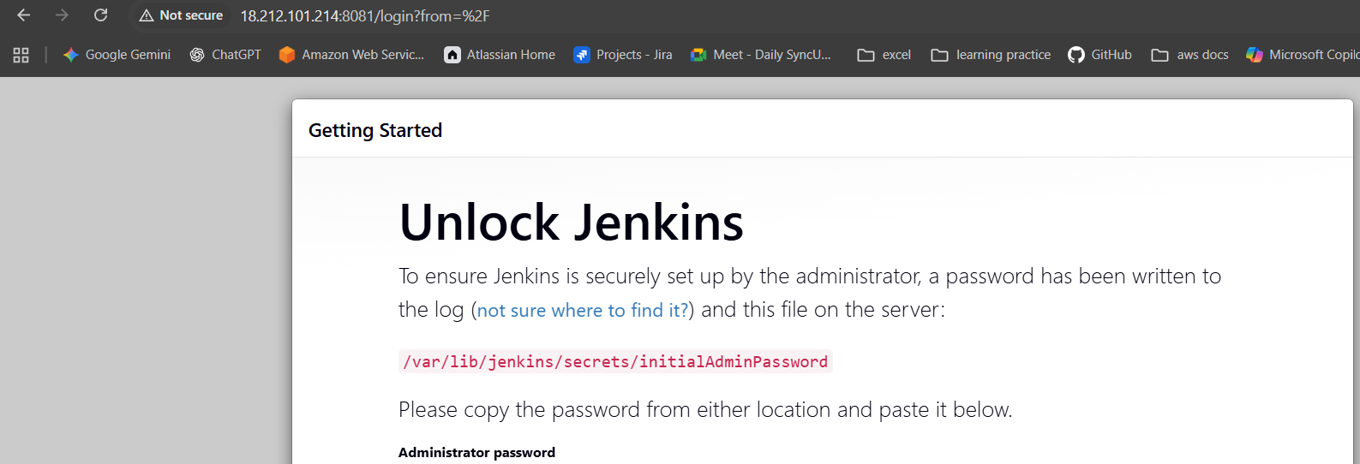
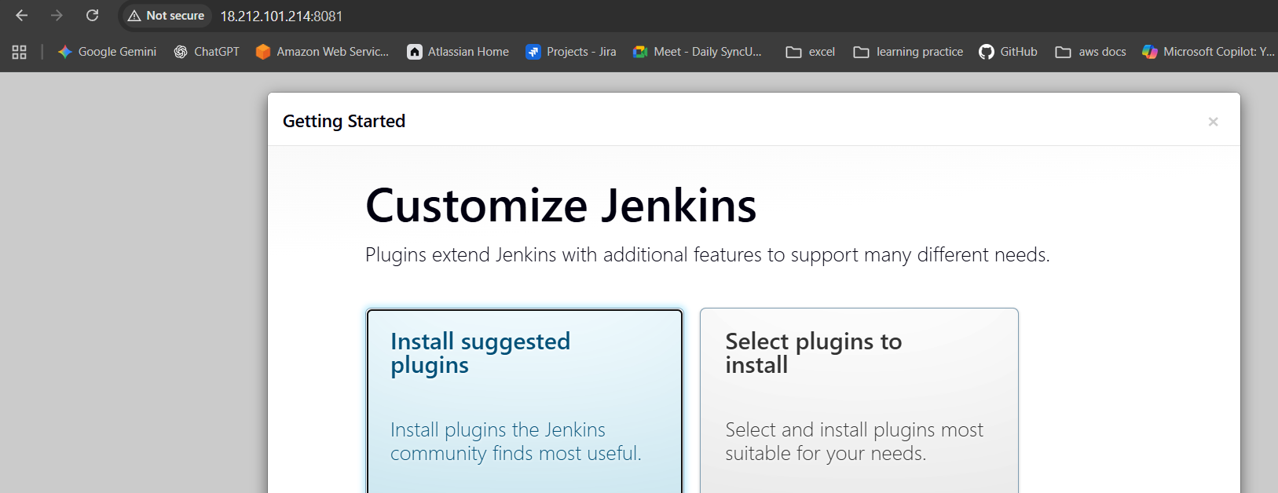
Conclusion::
Jenkins was installed successfully and configured to run on port 8081, and the service is running properly and accessible through the browser.

Title:
Secure Jenkins server
Objective:
To secure the Jenkins server by restricting unauthorized access, configuring proper authentication and authorization, securing network access, and protecting sensitive credentials to ensure safe and reliable CI/CD operations
Prerequisites::
- Jenkins
- Create Admin User
Step By step Implementation::
Step 1: Click on Suggested Plugins and continue to install
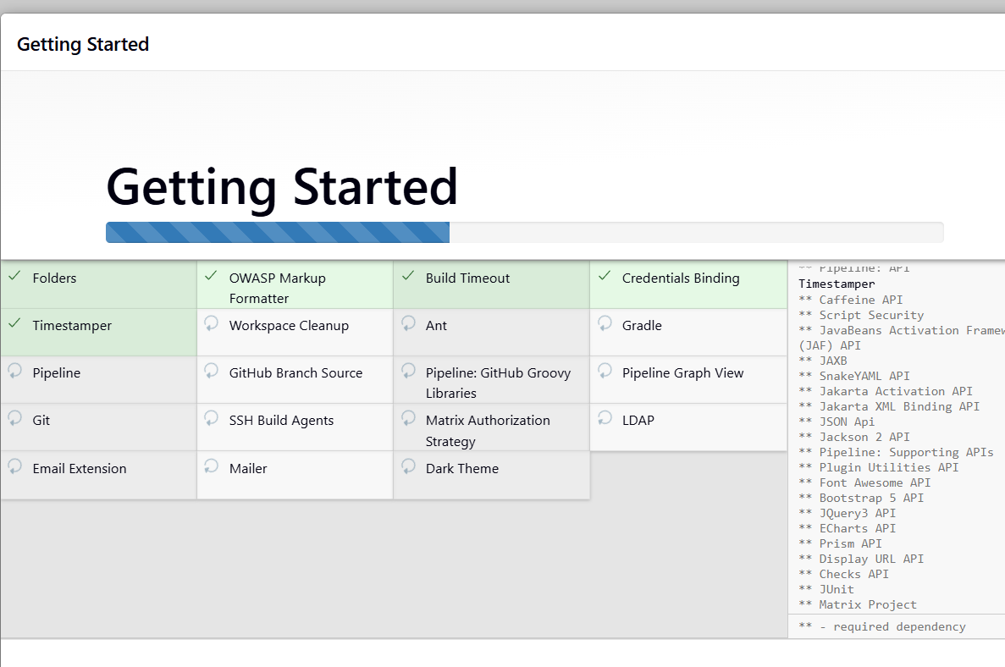

Step 2: Create a ADMIN User and provide the details and submit
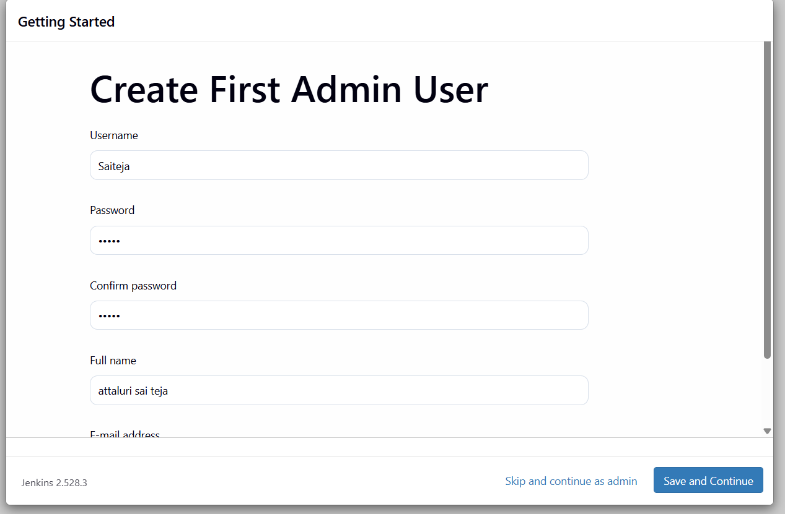
This is my ADMIN DASHBOARD
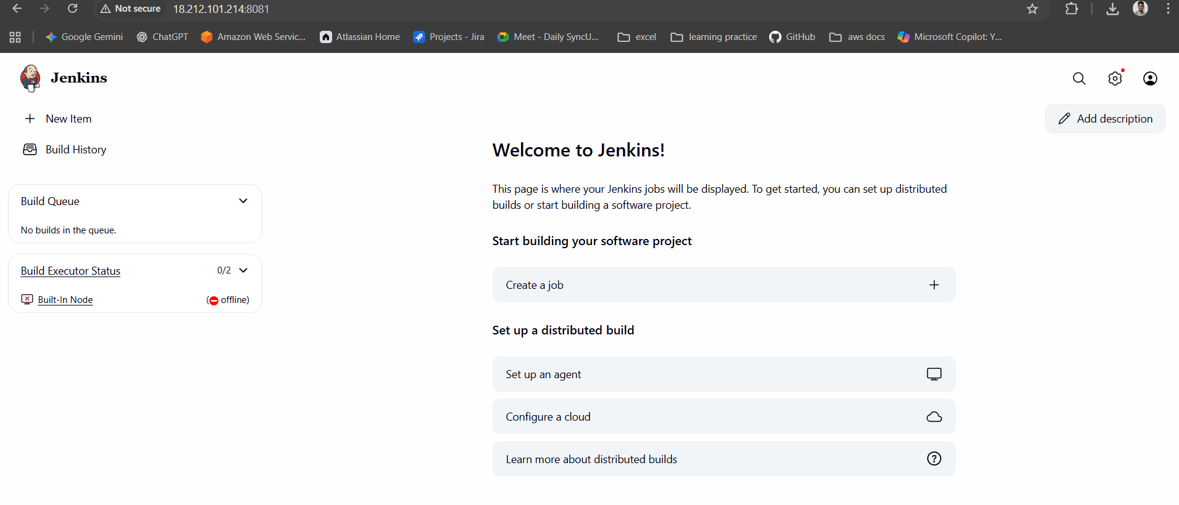

Validation Step:: Earlier there was a file called InitialAdminPassword as you can see in below document but after Securing by creating ADMIN User the file was not visible
So that our JENKINS is Secured with our USERNAME AND PASSWORD

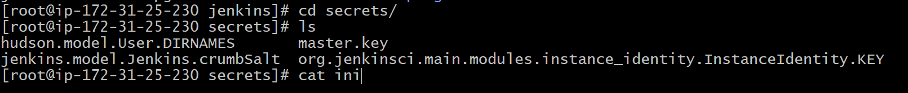
Conclusion:
The Jenkins server was successfully secured by applying access controls, enabling authentication, restricting network ports, and safeguarding credentials. These measures reduce security risks and ensure that Jenkins operates in a safe and controlled environment suitable for production use.

Title:
Create users called DevOps, Testing in Jenkins with Limited access.
Objective:
To create Jenkins users named DevOps and Testing and assign them limited access by configuring role-based permissions, ensuring users can perform only authorized actions according to their responsibilities.
Prerequisites:
- Jenkins
- Plugins (Role -based)
Step by Step Implementation:
Step 1: Navigate to Jenkins Dashboard.
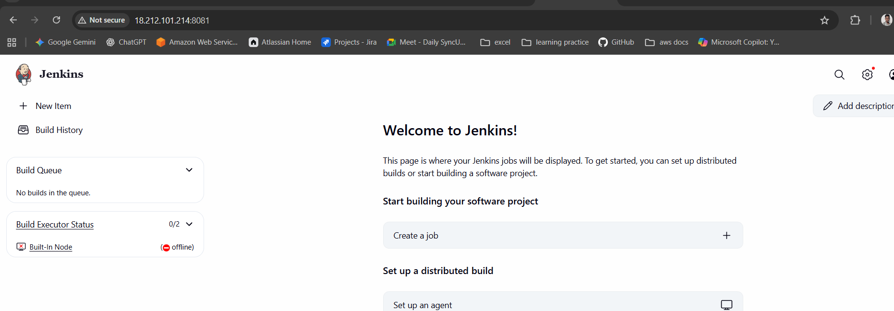
Step 2: Click on Settings and navigate to Users tab and click on it
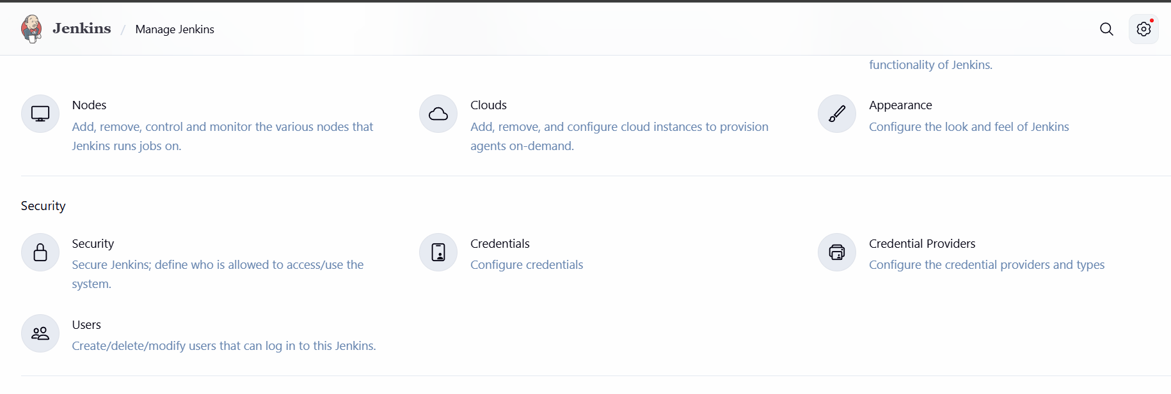

Click on Create Users and create user named DEVOPS AND TESTING
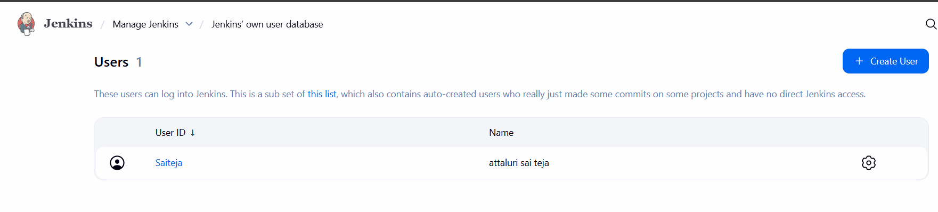
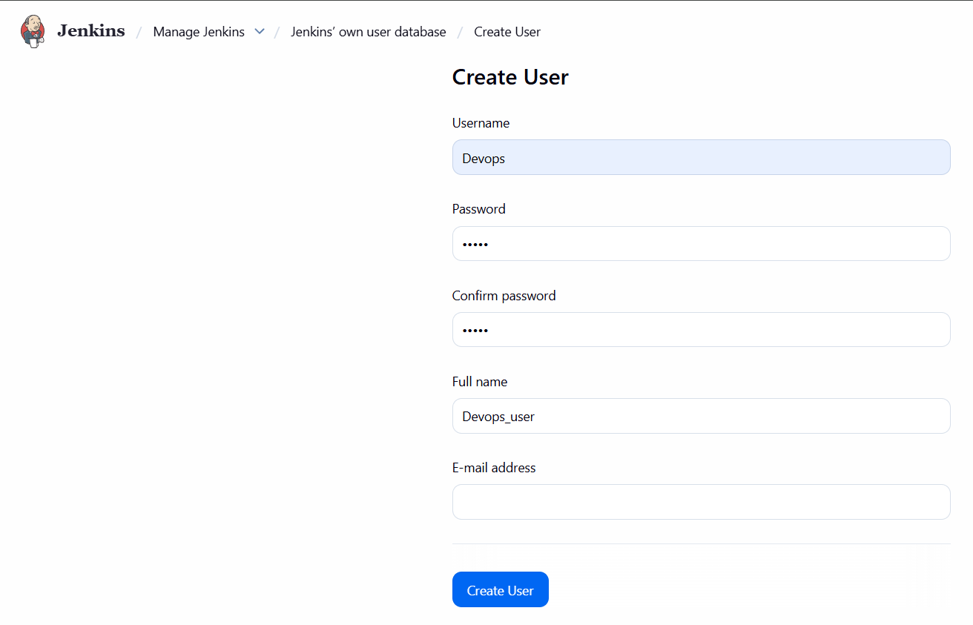
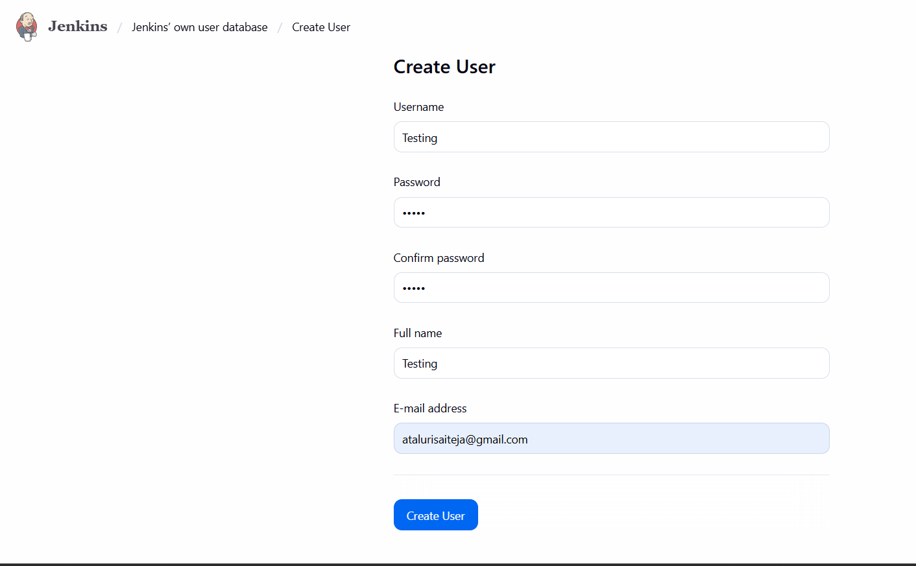
Created Two Users
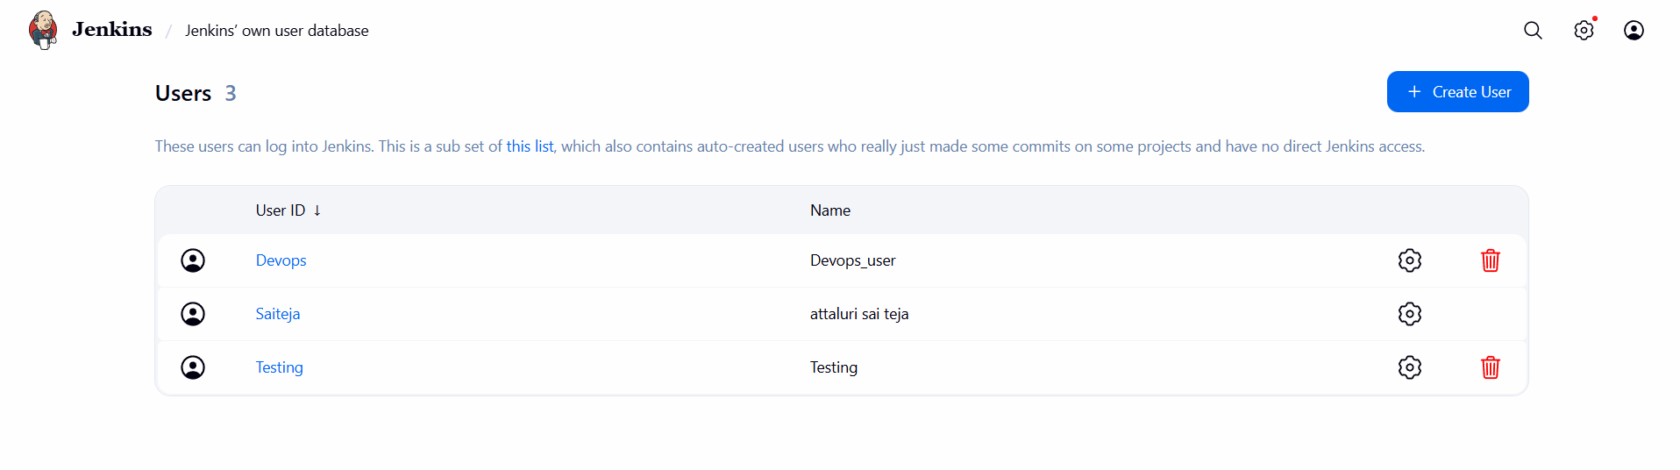
Step3:
Install REQUIRED PLUGINS TO give Limited access to USERS
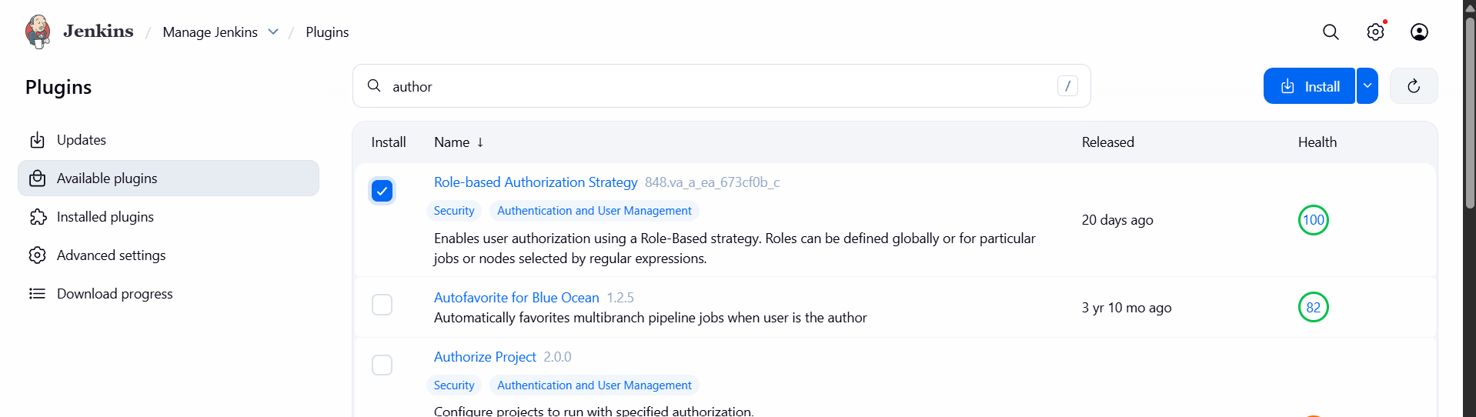.

Click on Go BACK TO TOP PAGE
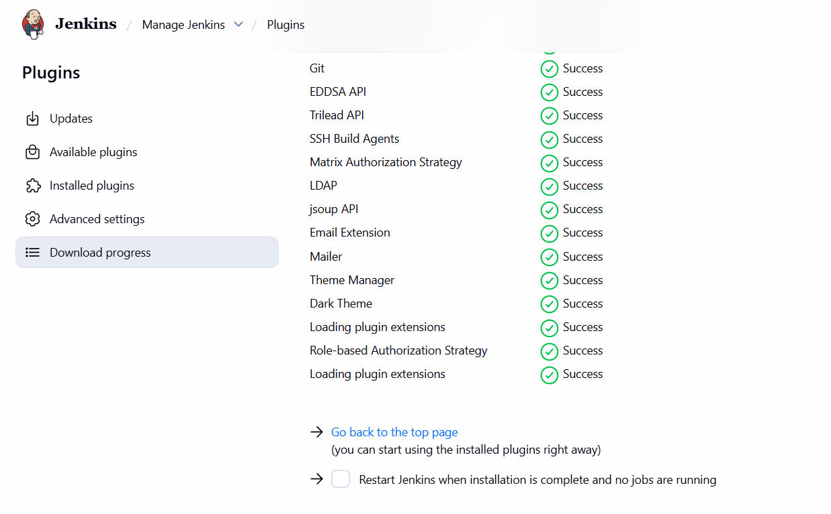
Step 4:
Go back to SECURITY and Select Authorization tab and select the option called
Project based Matrix Authorization Strategy
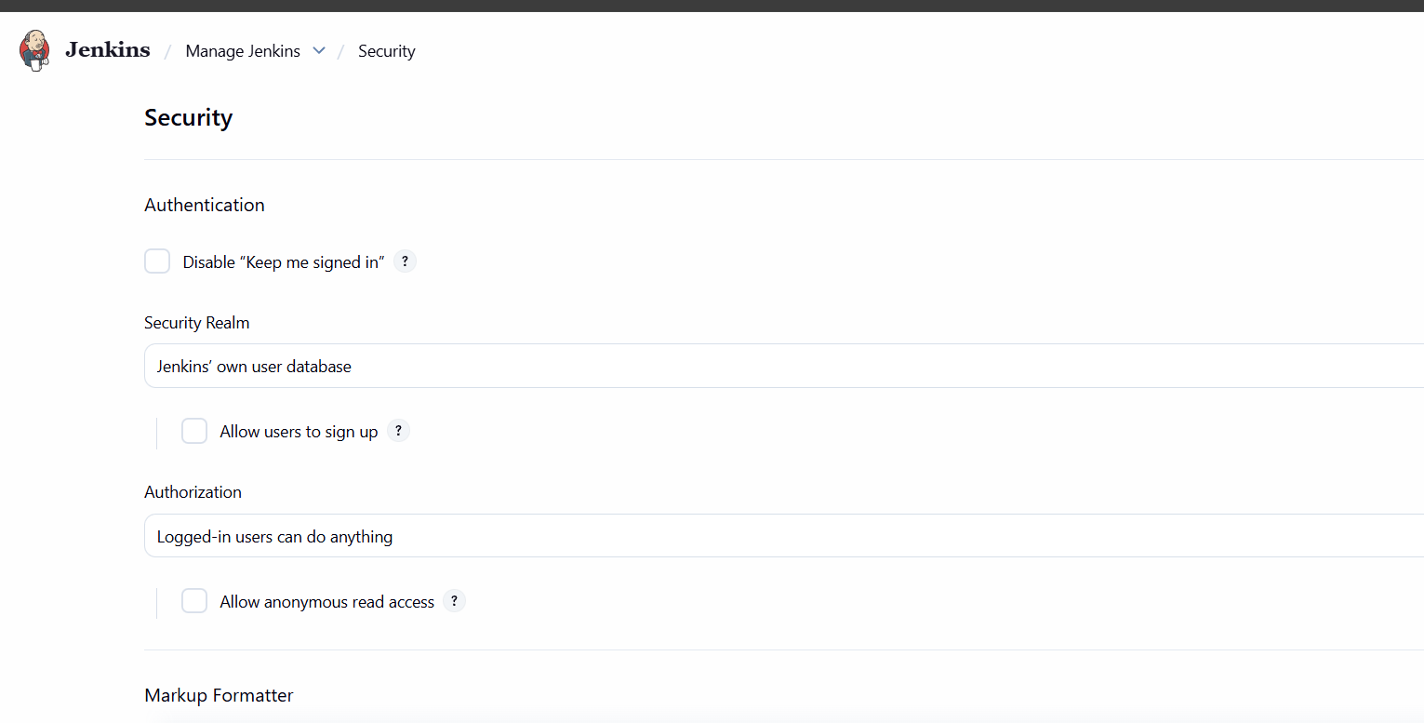

Click on ADD user and provide the username and give the least privilages and click on save
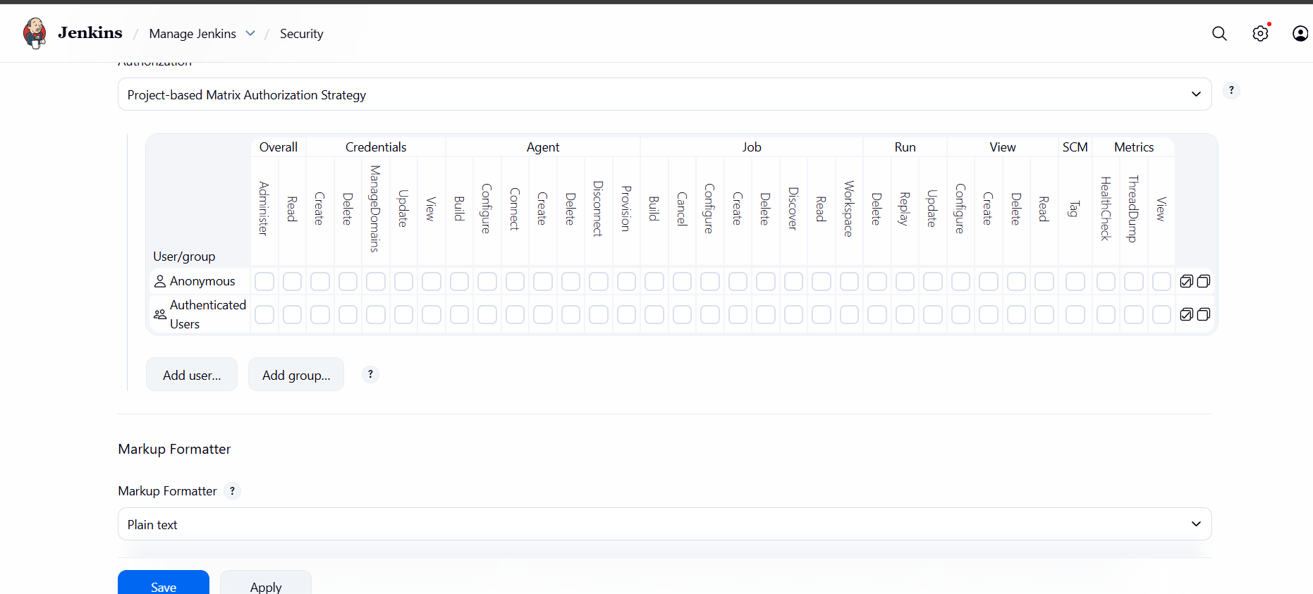
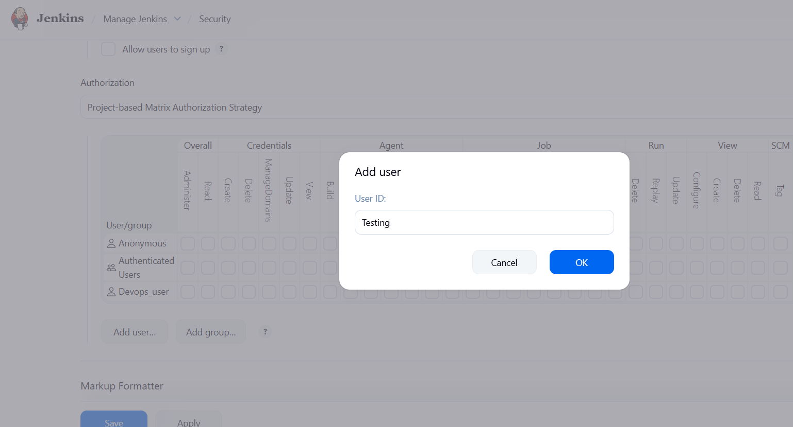
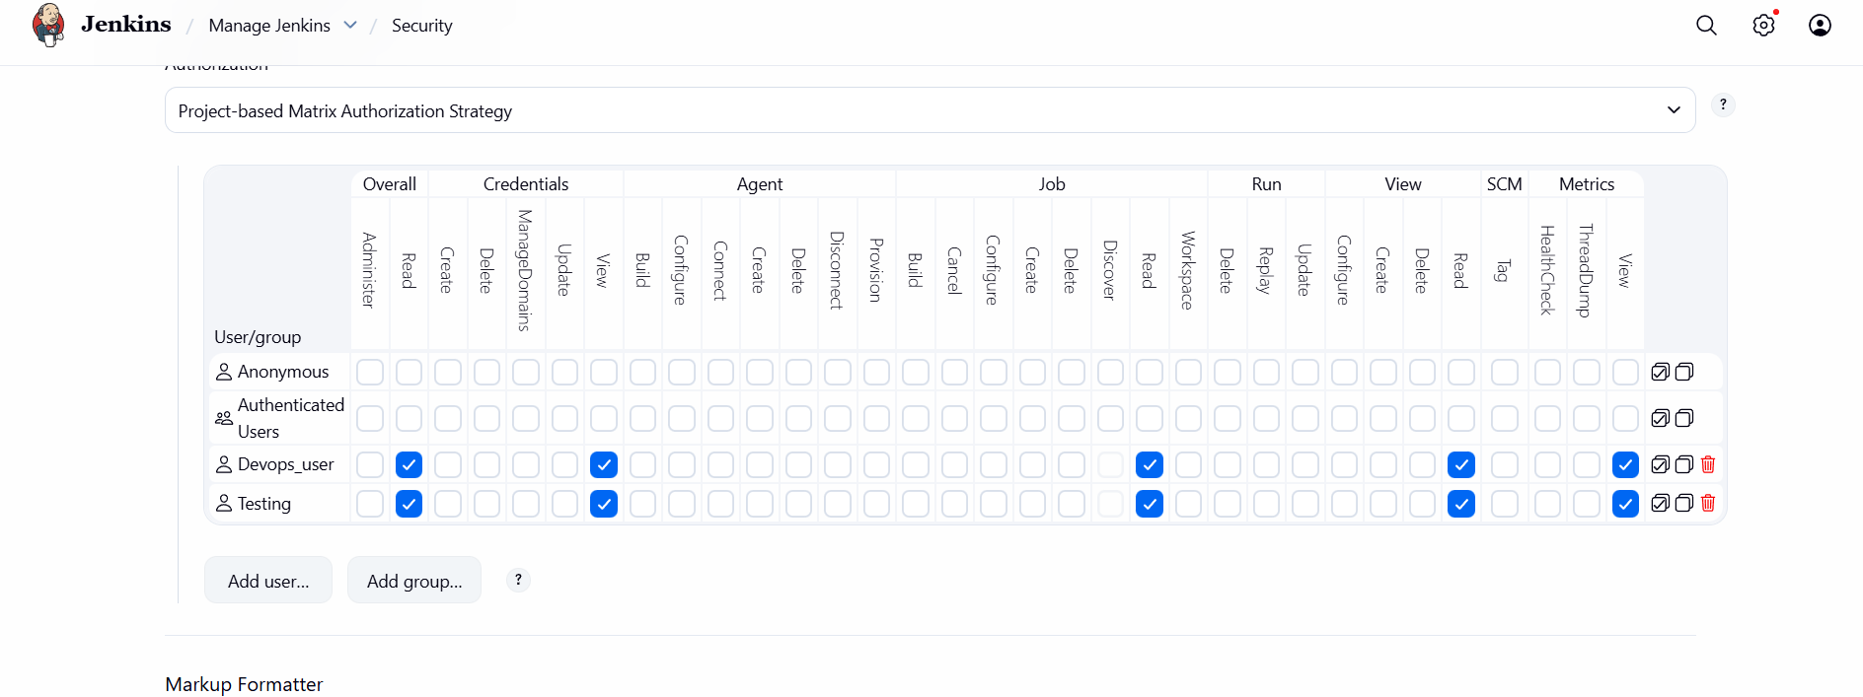

Validation Part:
Before Providing LIMITED ACCESS the user can do anything he need
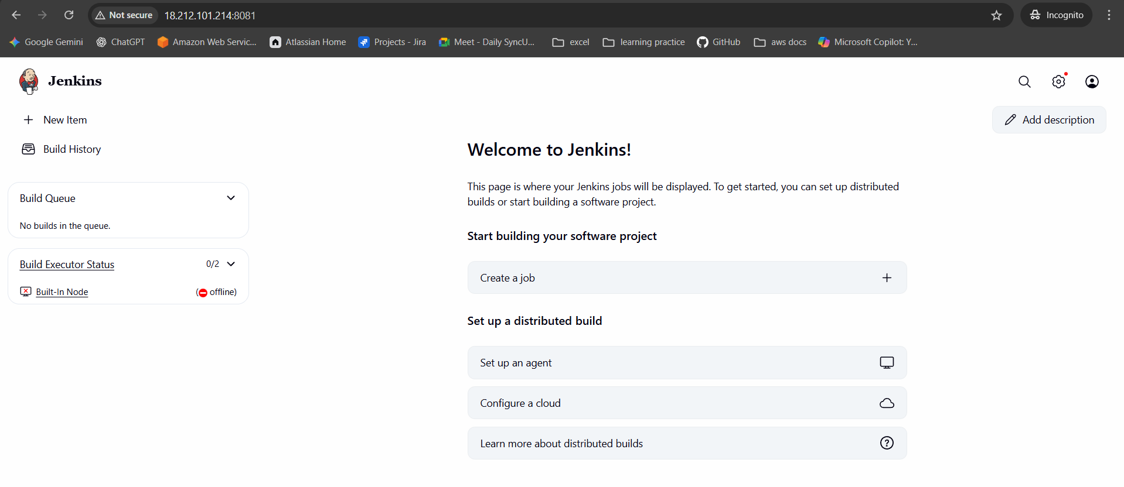
After Providing Only he can read or view the files
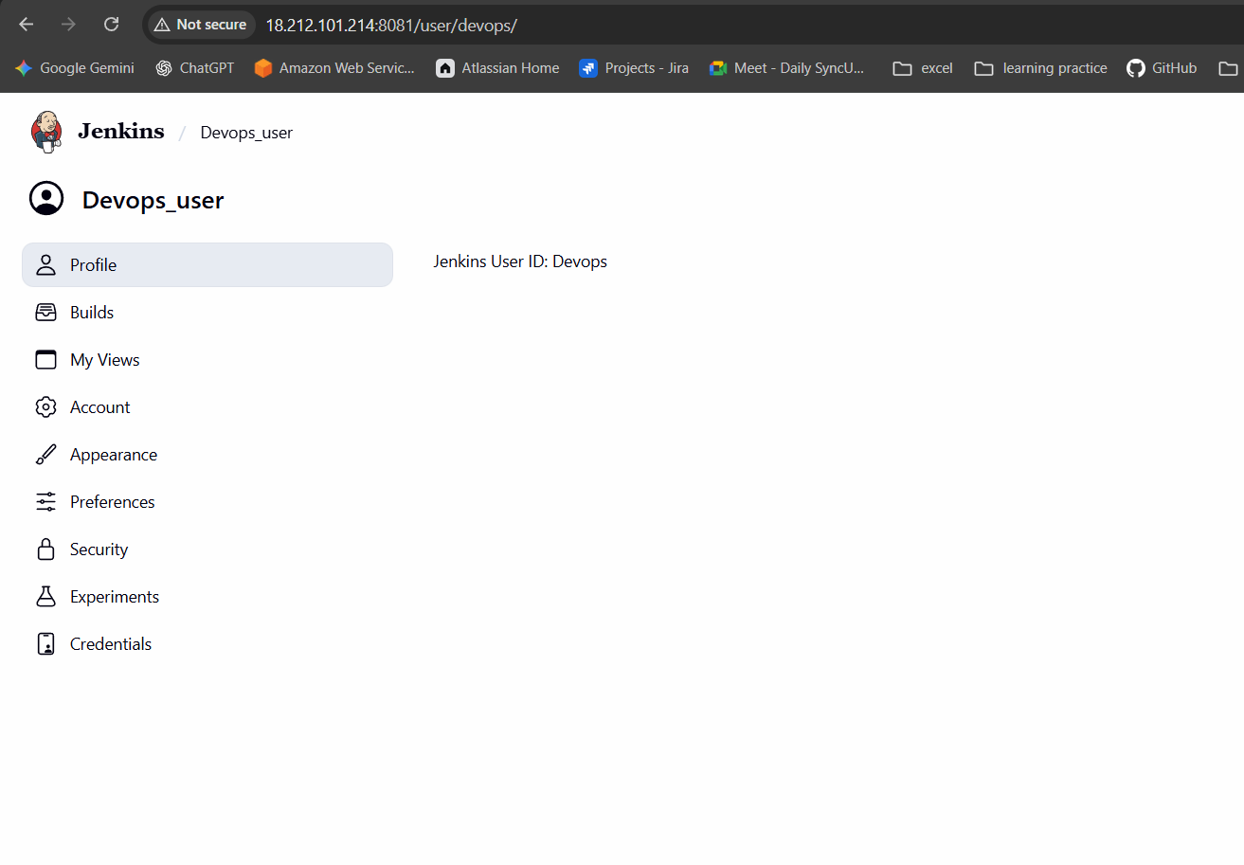
Conclusion:
The users DevOps and Testing were successfully created in Jenkins and assigned limited permissions using role-based access control. This setup improves security by preventing unauthorized changes while allowing users to perform their assigned tasks effectively.
Title:
Configure labels and restrict the jobs to execute based on label only.
Objective:
To configure node labels in Jenkins and restrict jobs to execute only on specific labeled nodes, ensuring controlled job execution based on resource type, environment, or purpose.
Prerequisites:
- Jenkins
- Plugins
- Github
Step by Step Implementation:
Navigate to JENKINS and Install Node and Label Parameter Plugin.
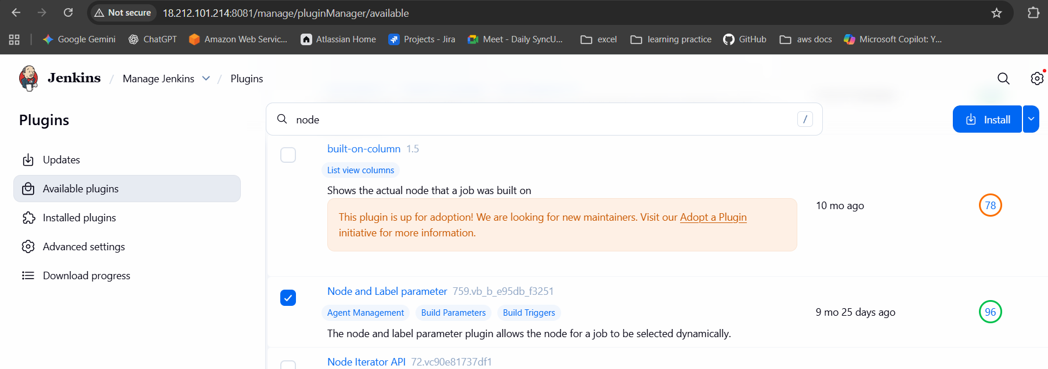
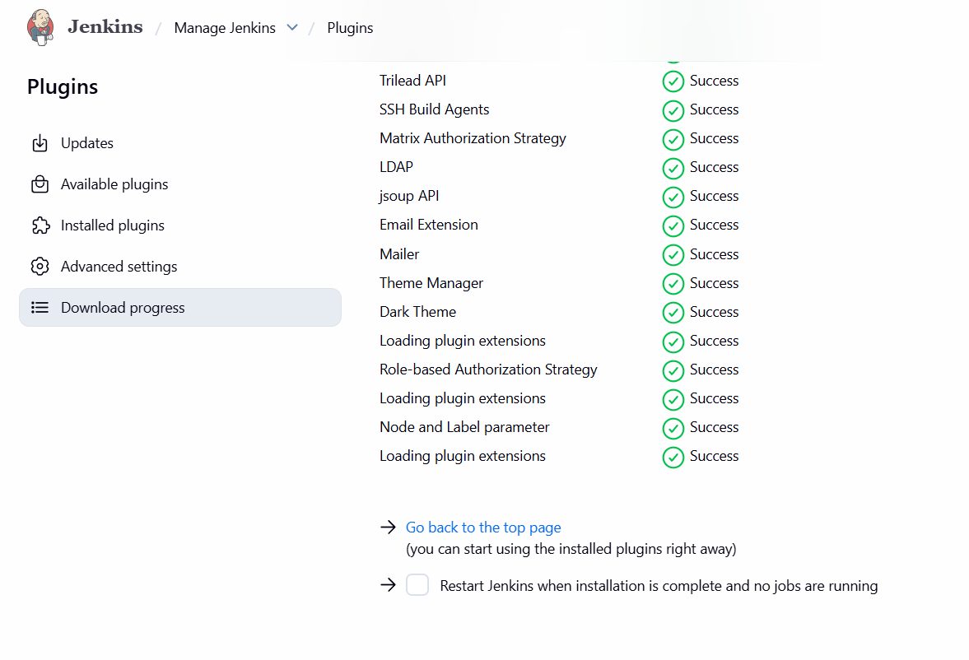
Navigate to System and provide a system message and label and save
Click on USAGE and select the option and continue
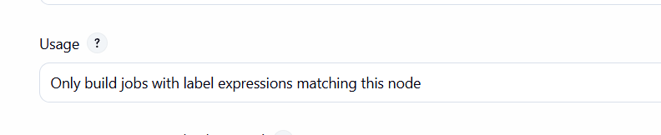
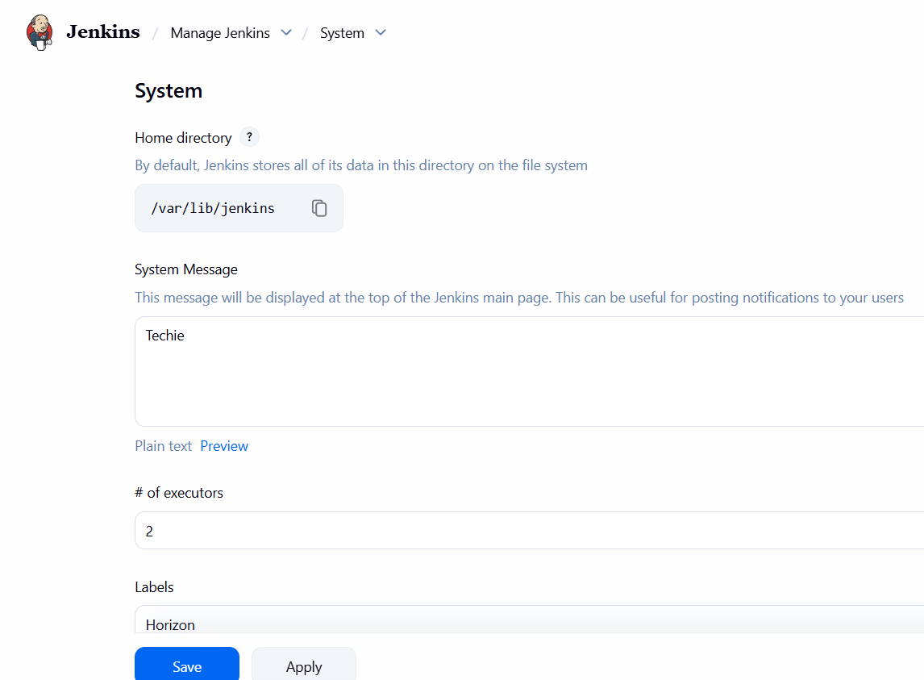

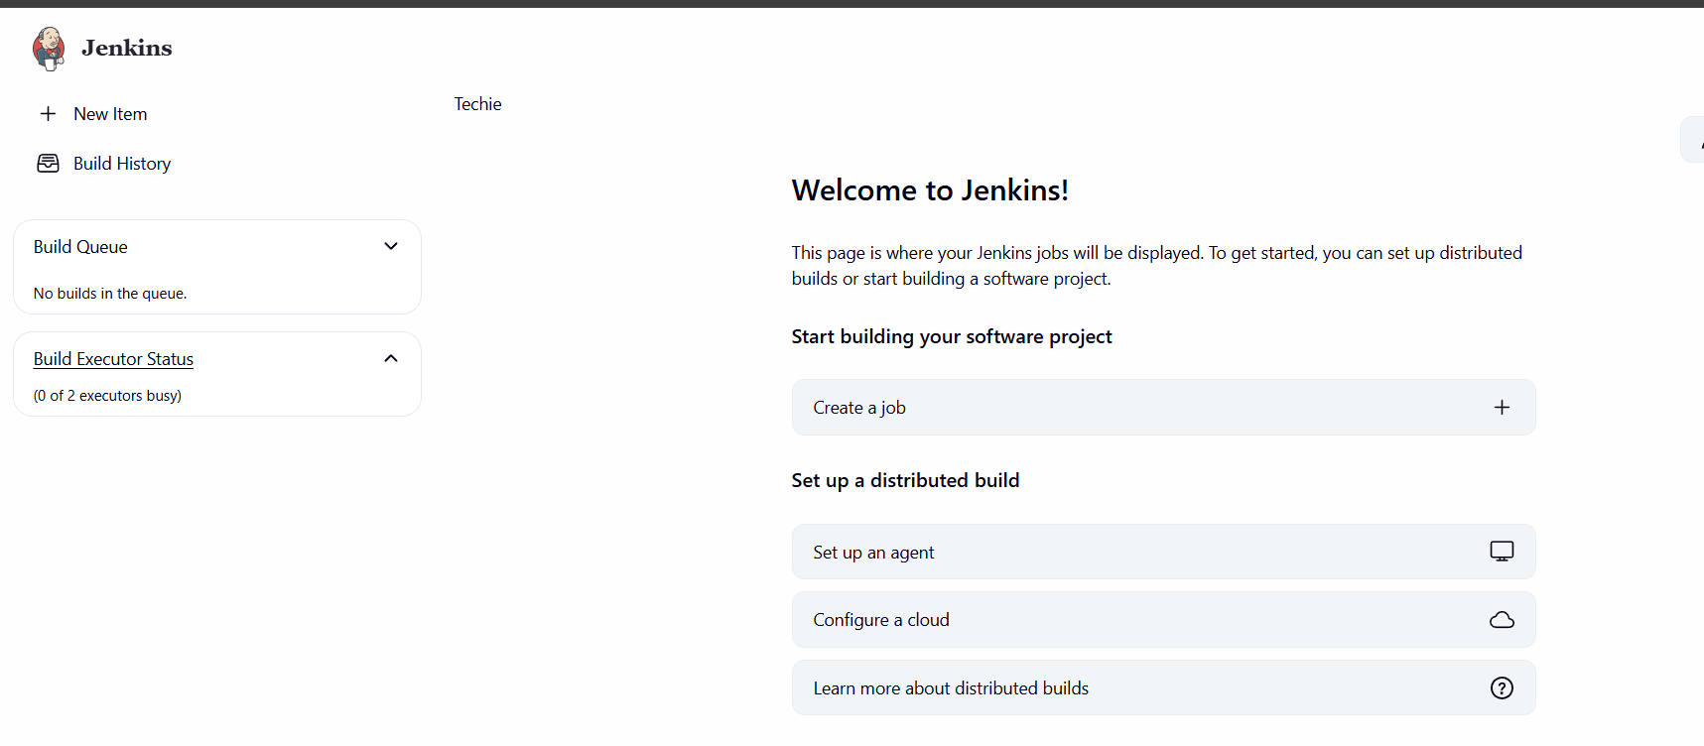
Step 1: In the Dashboard Click on create a job or New item and enter the name and select the item type as freestyle and click on OK
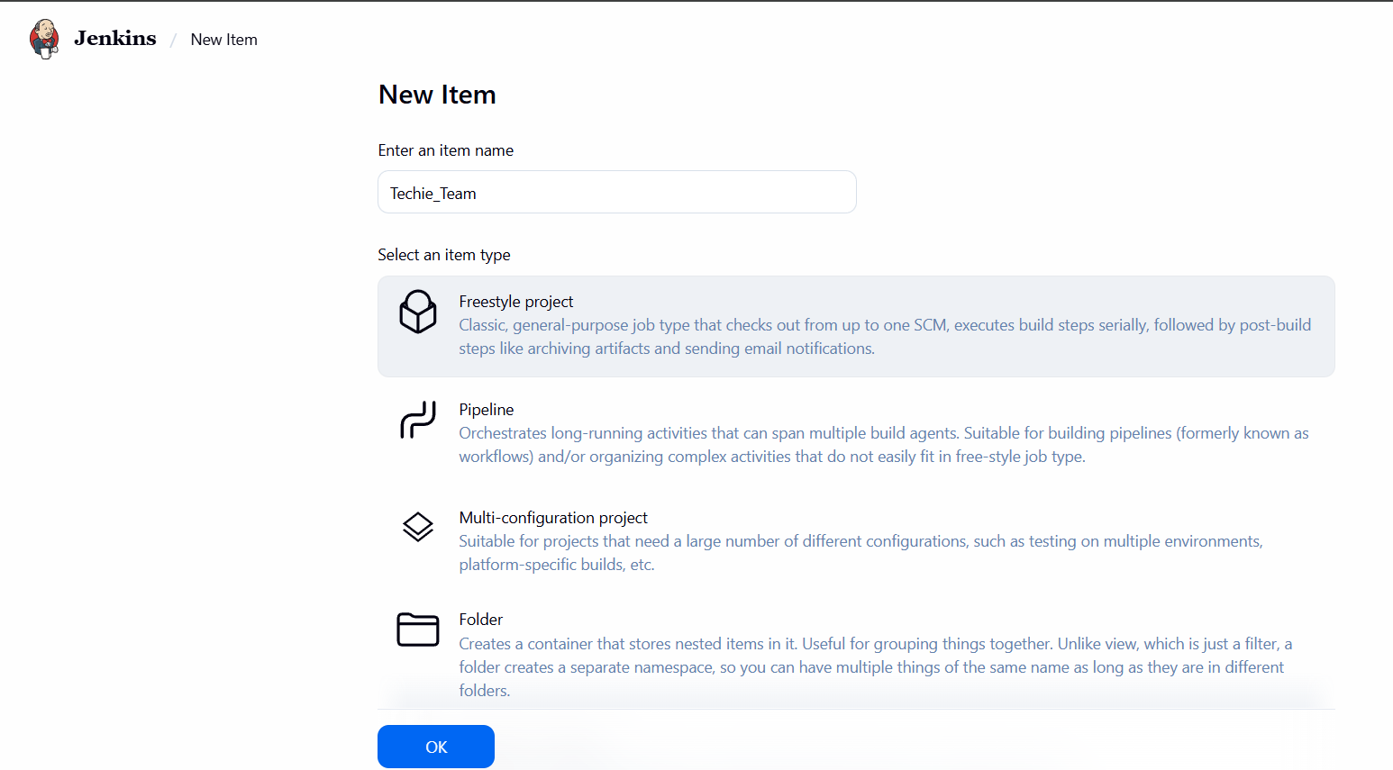

Select the Label which we created earlier and continue
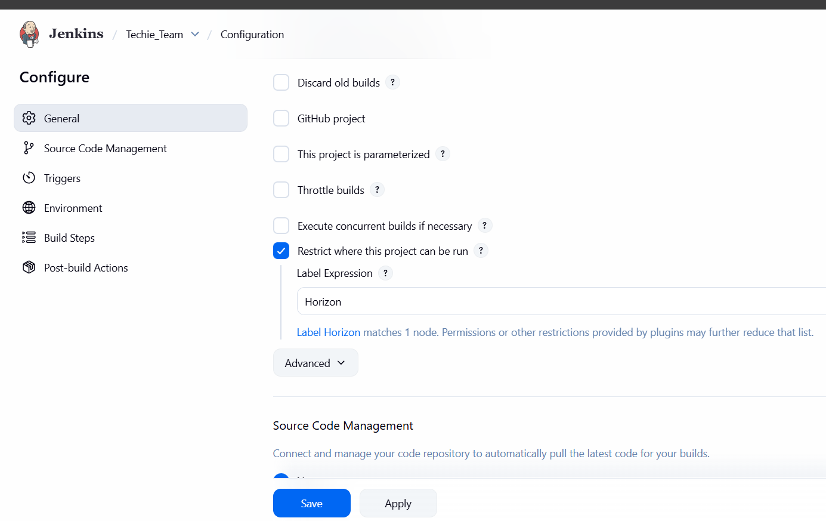
Step 2: After that Select the Option in Source code management as GIT and continue
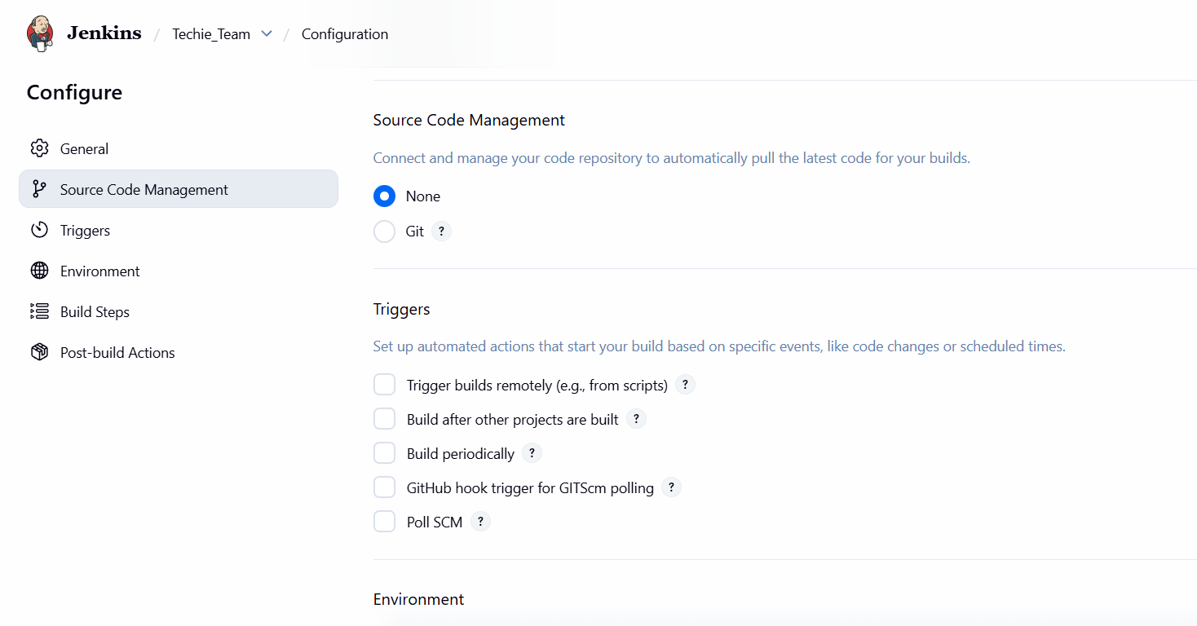

Step 3: Navigate to Github and copy the repo link
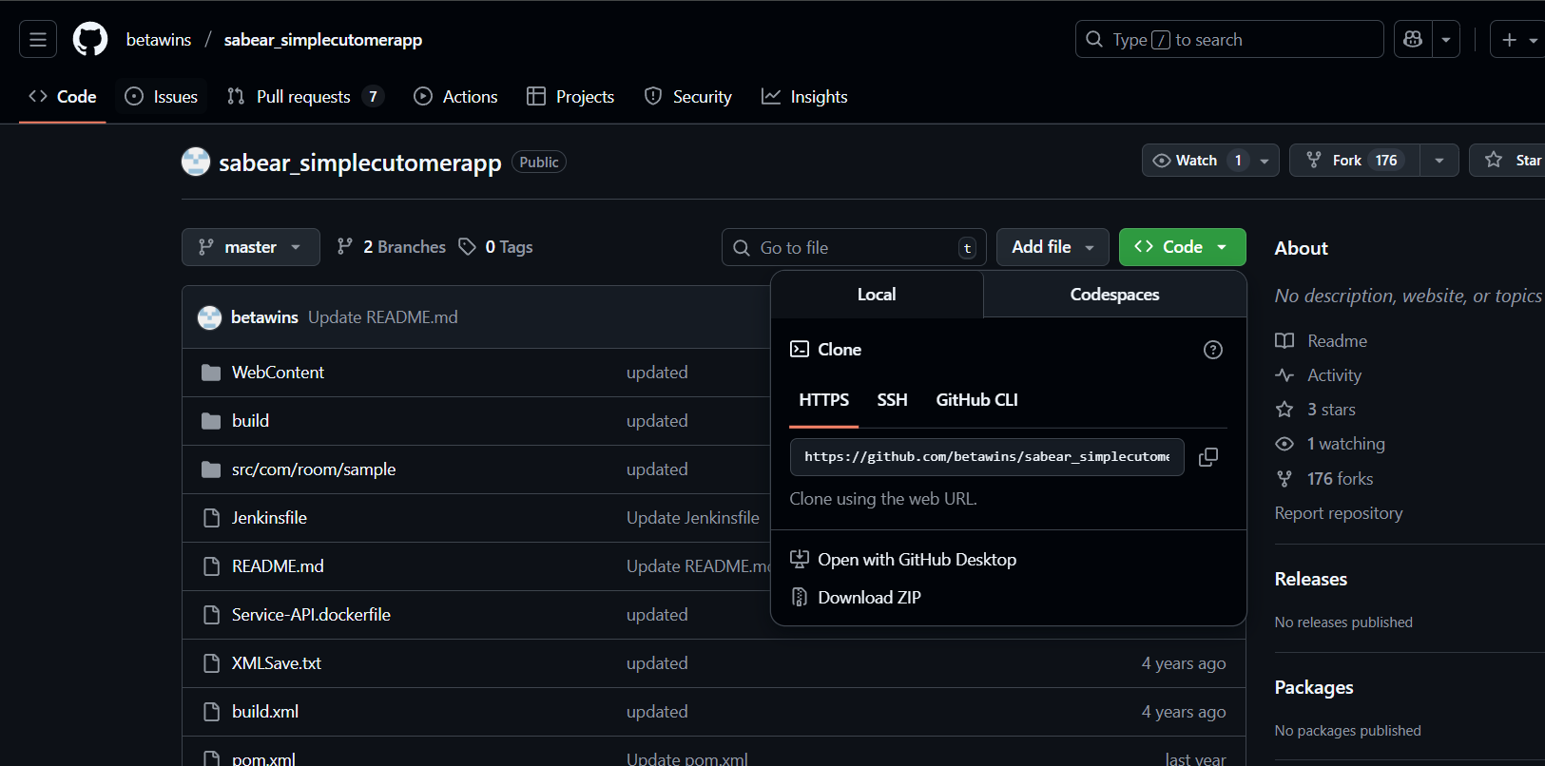
Paste the link over repository URL
We can see an error that failed to Connect to Repository
Lets remove the error by installing git in CLI
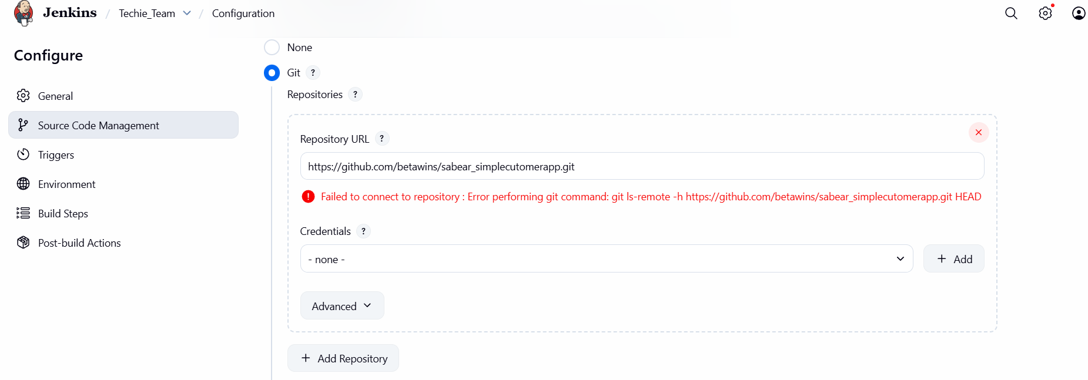

Step 4: Use command Yum install git -y to install git and refresh the Jenkins web page to update the changes
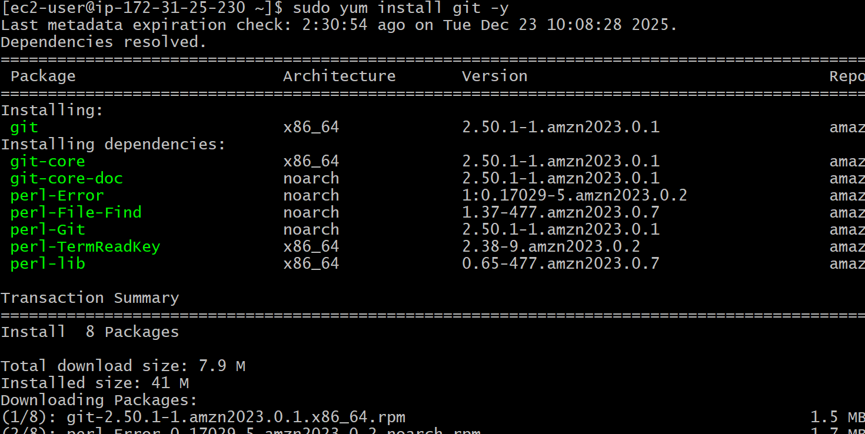
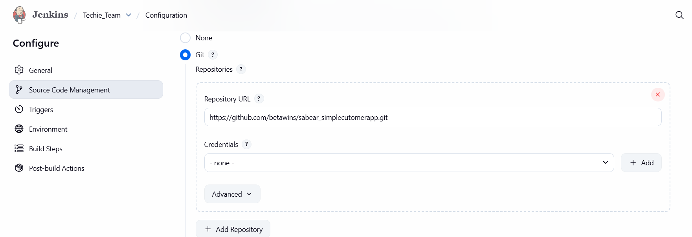
Step 5: After the setup click on save
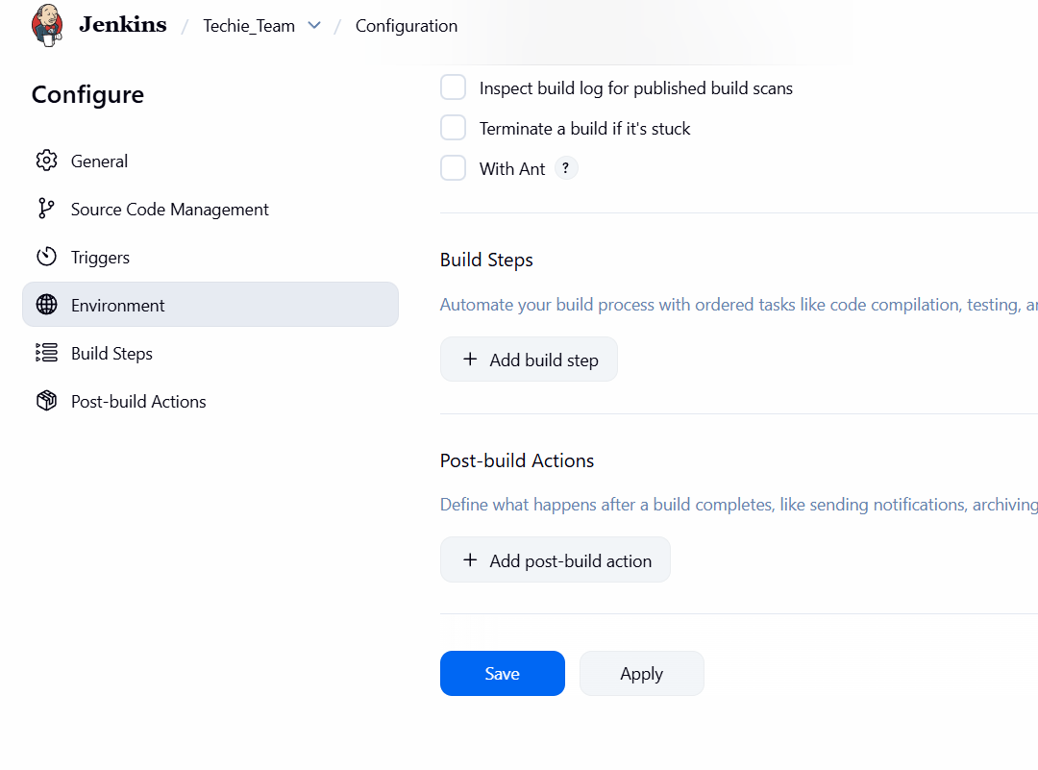
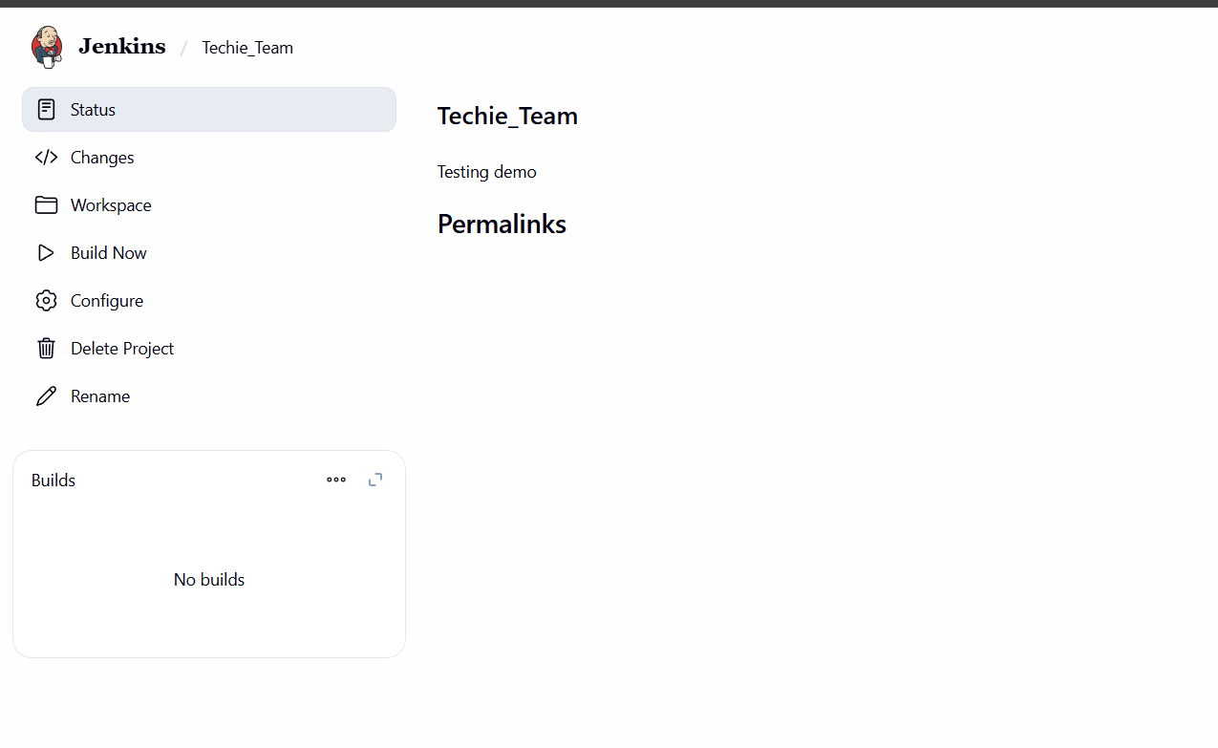
Step 6: Click on build an check the console output and see the details
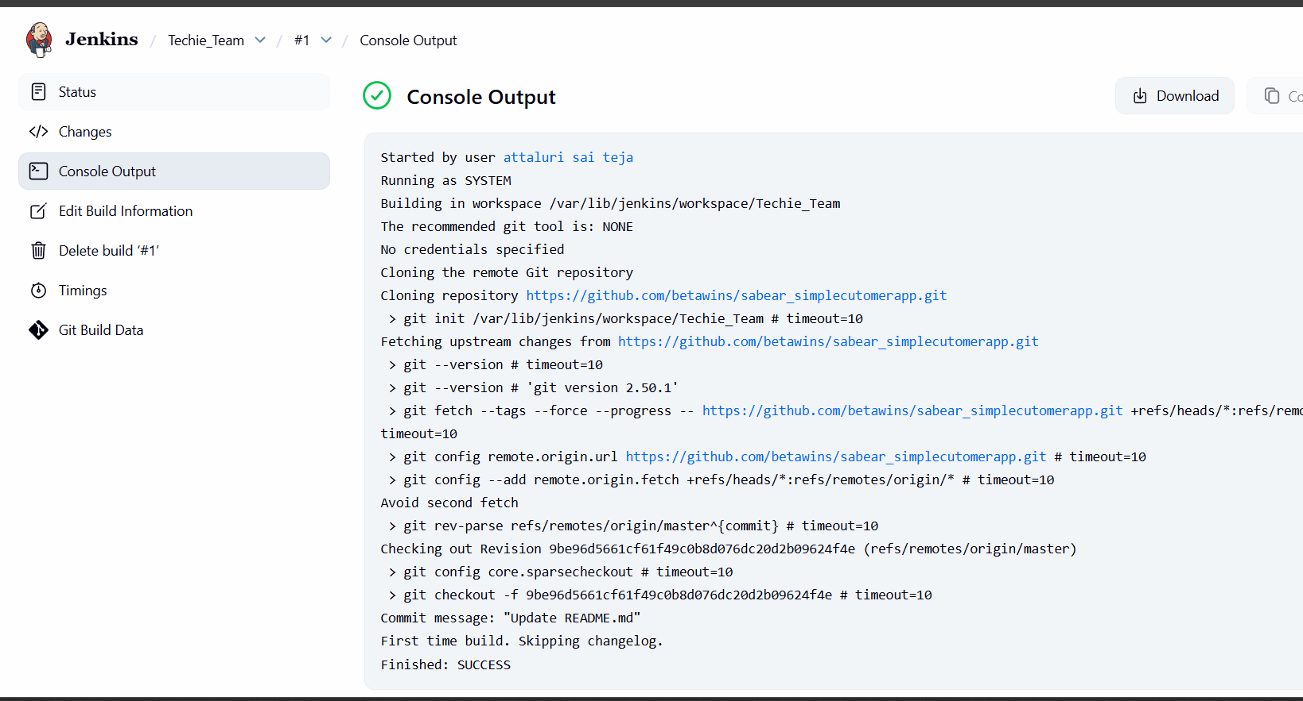

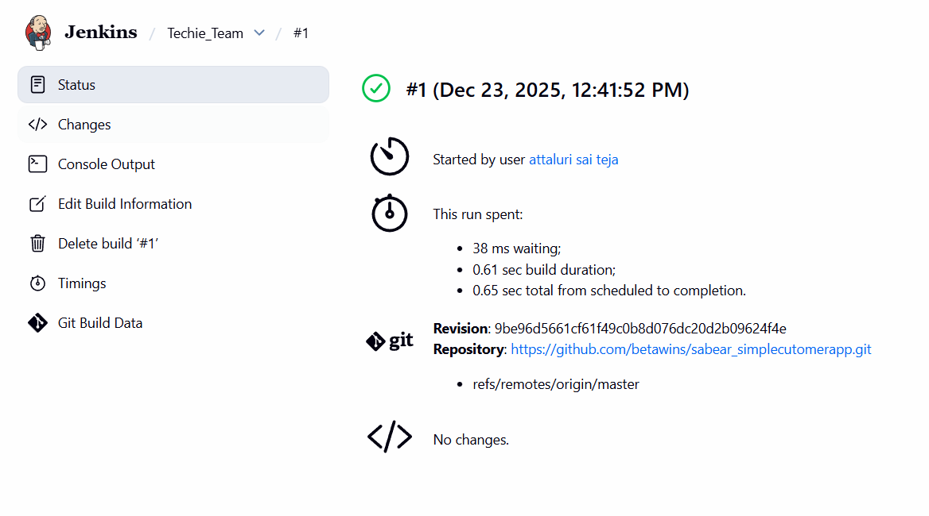
Step 7: in the Nodes the job is in active stage
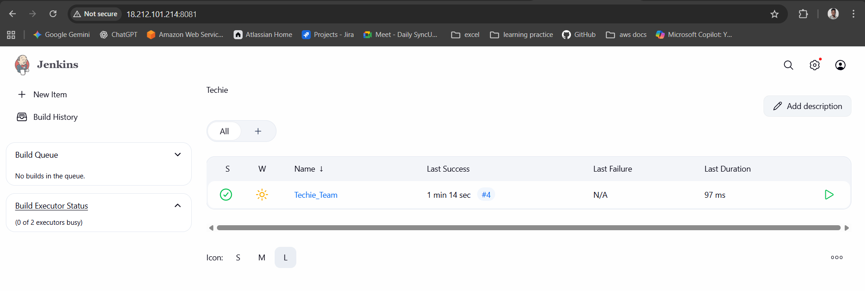
Conclusion:
Node labels were successfully configured in Jenkins, and jobs were restricted to run only on the specified labeled nodes. This ensures better resource management, controlled execution, and efficient utilization of Jenkins infrastructure.

Title:
- Create Three sample jobs using the below URL. https://github.com/betawins/Techie_horizon_Login_app.git
Objective:
To create three sample Jenkins jobs in order to understand basic job creation, configuration, and execution within the Jenkins environment.
Prerequisites:
- Jenkins
Step by Step Implementation:.
Navigate to Dashboard and click on New item and create Multiple new job as same we done in earlier task
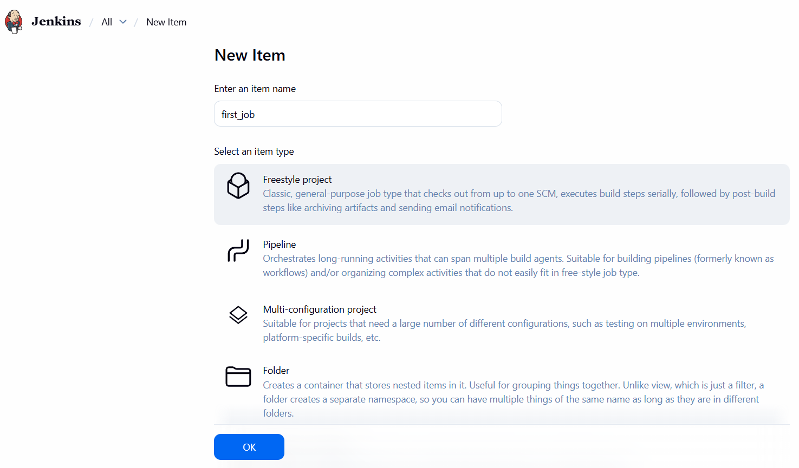
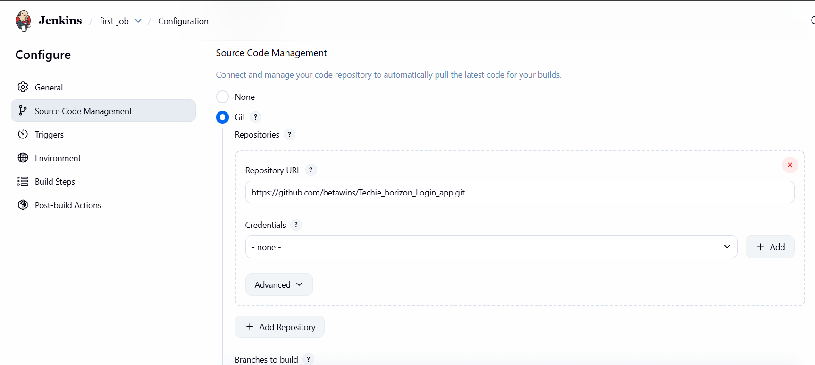
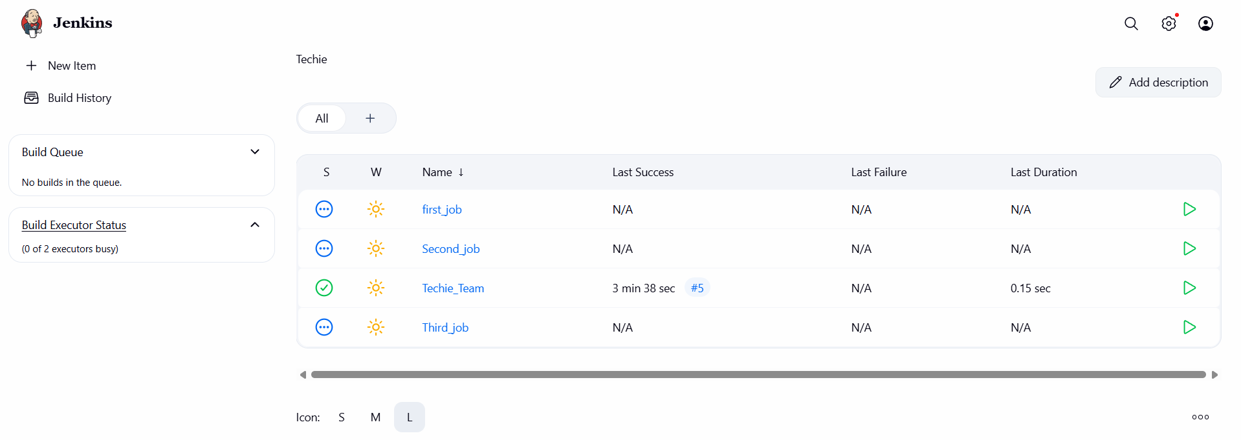
Click on Pause symbol to BUILD
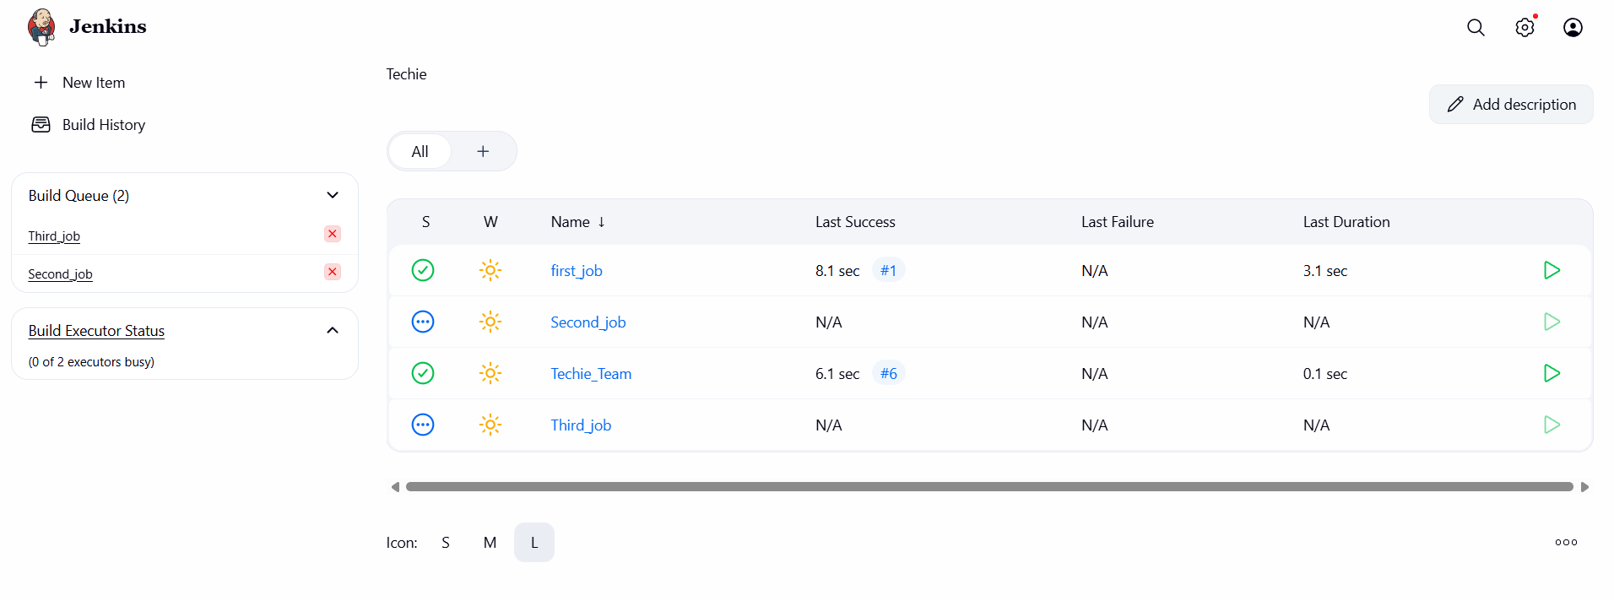

If you see the dashboard it showing that 2 jobs are completed and 2 jobs are pending because I didn’t configured labels in both jobs
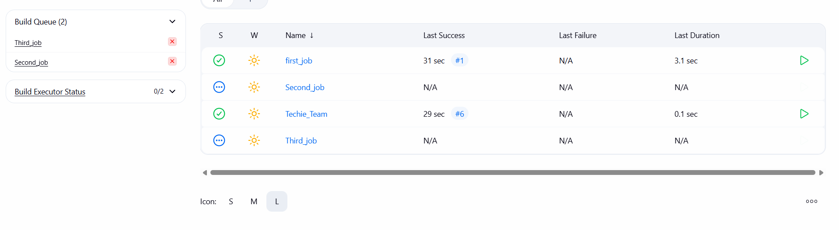
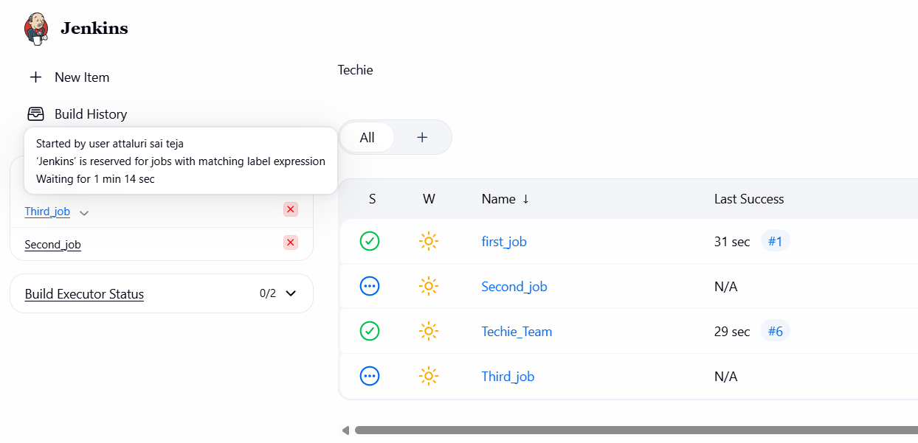
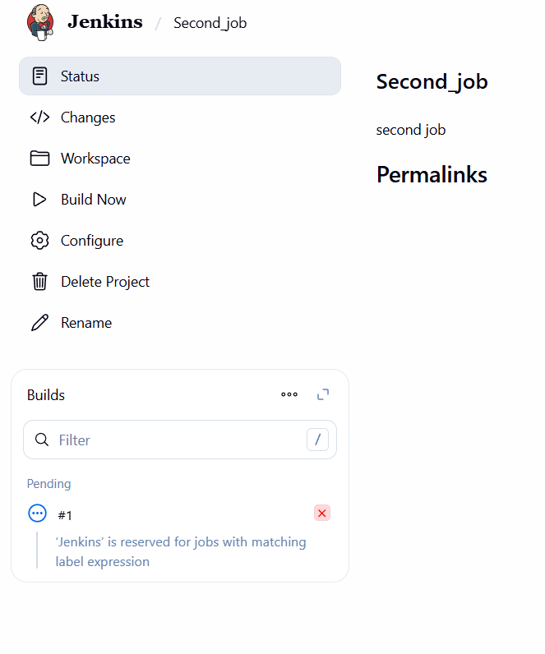
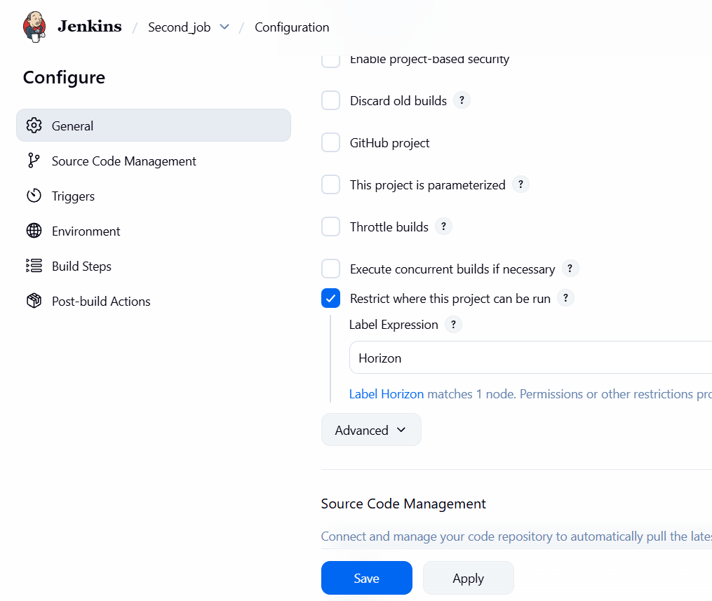
After adding lables the builds was successfull
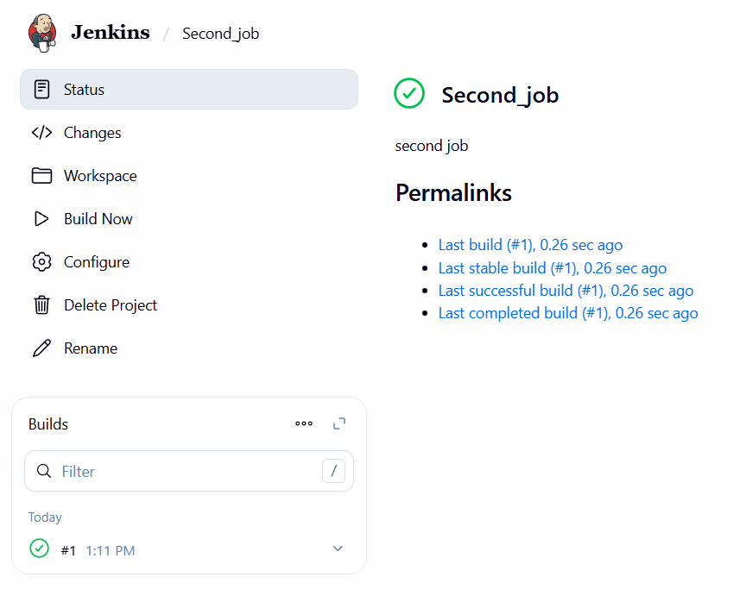
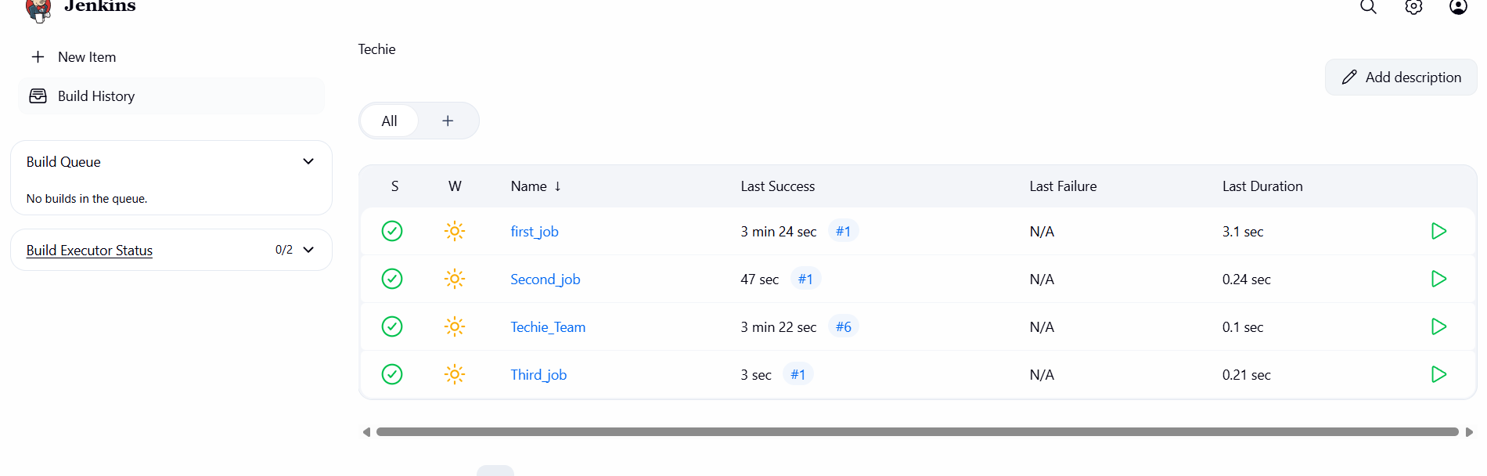
Conclusion:
Three sample Jenkins jobs were successfully created and executed, confirming proper Jenkins setup and validating the ability to configure and run jobs as required.

Title:
- Create one Jenkins job using git hub Private repository.
To create a Jenkins job that connects to a private GitHub repository using secure credentials and automatically pulls the source code for build execution.
Navigate to a private repositoey and copy the repo link
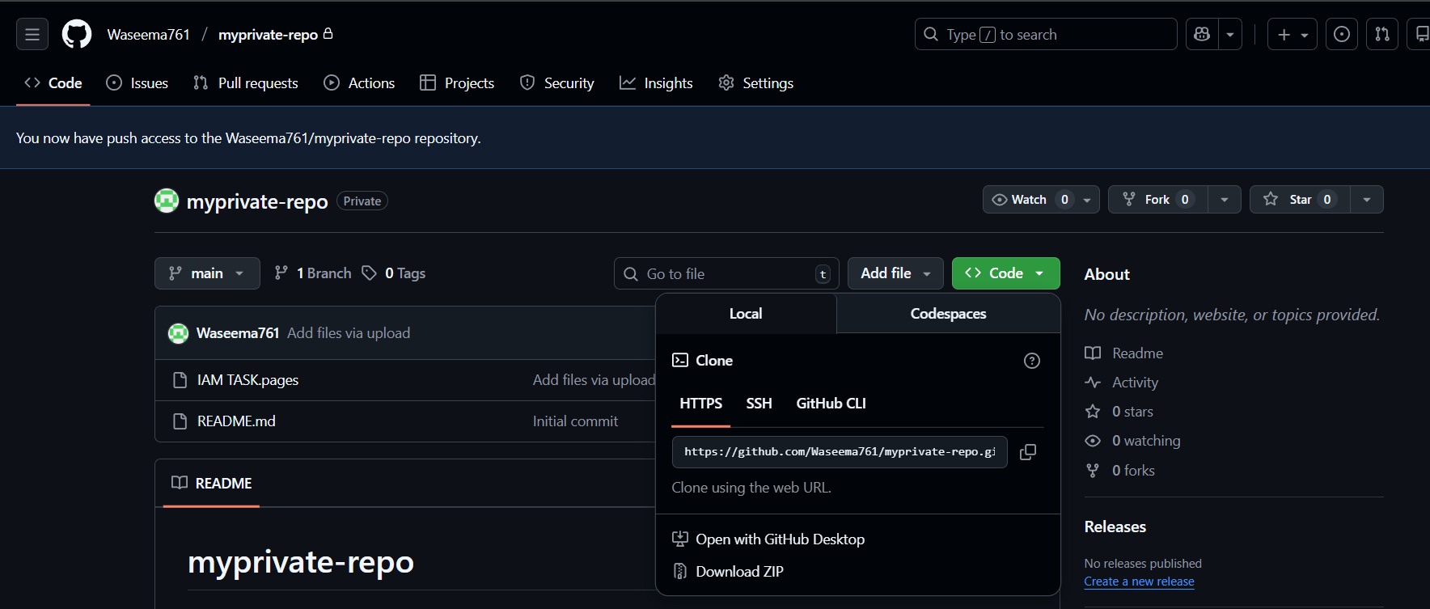
Create a credentials by adding repo username and token ( Generated in our github)
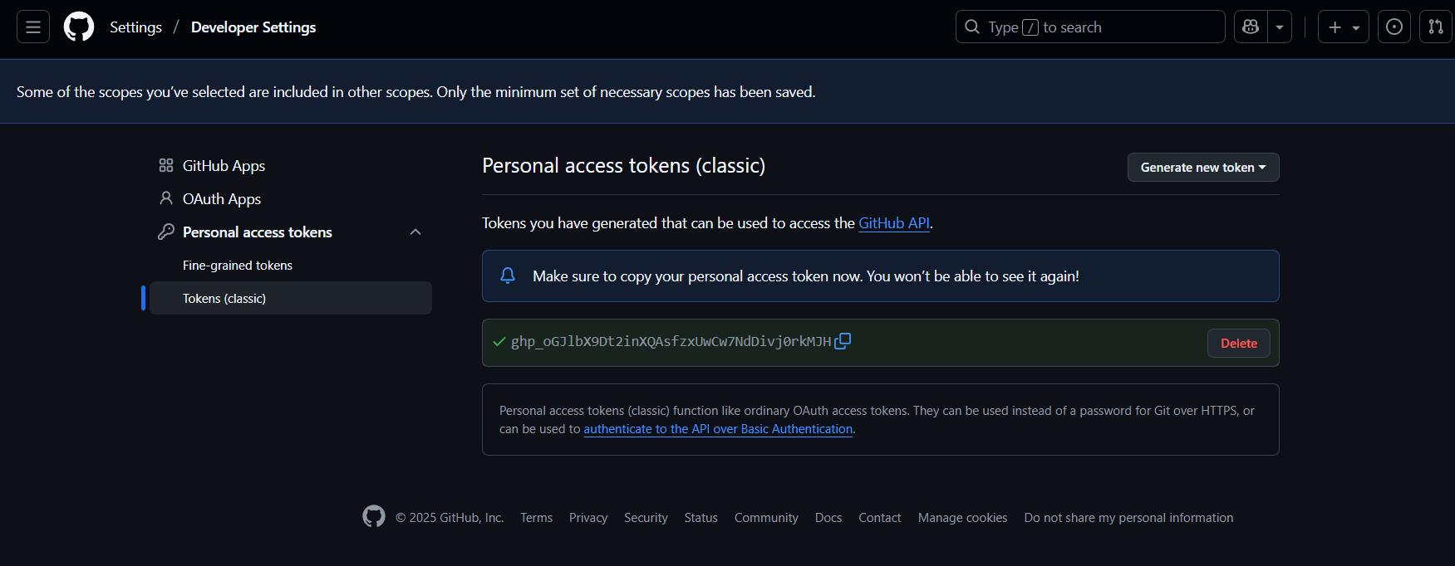
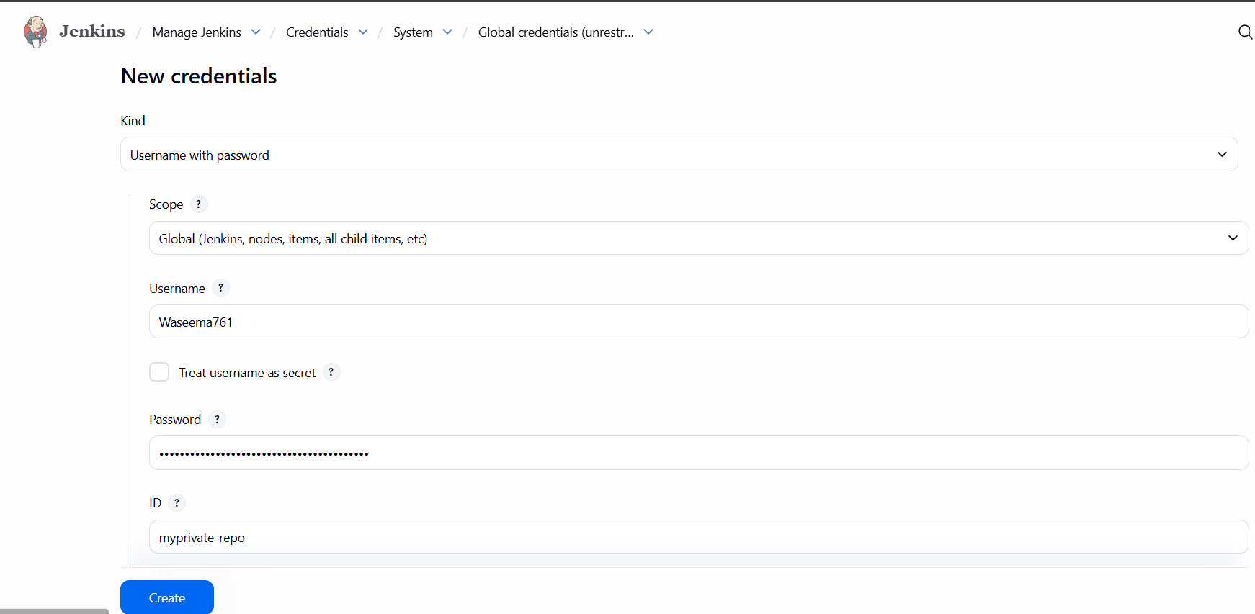
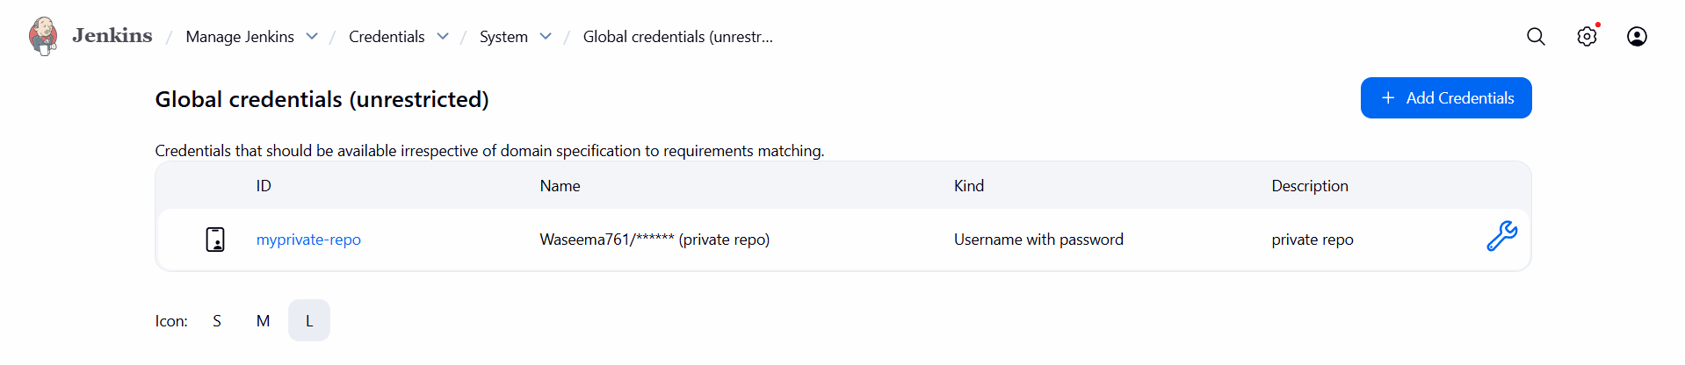
Create a new job same as earlier
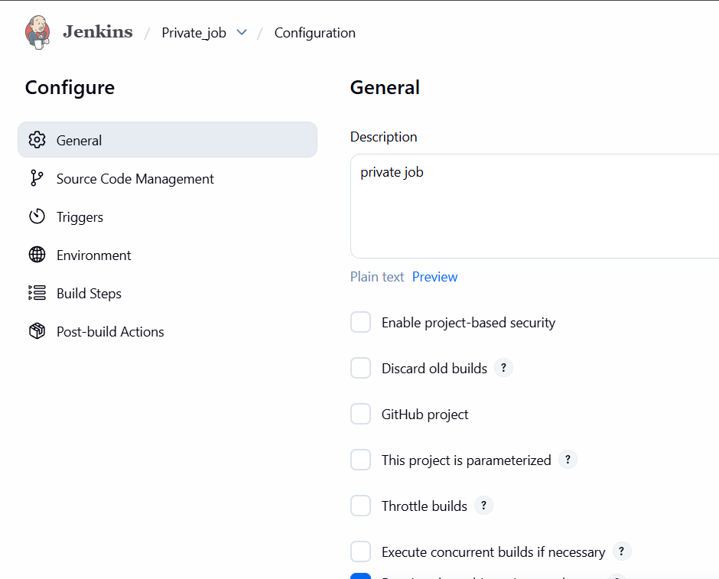

Continue the process by adding private repo link and click on add credentials and add the values
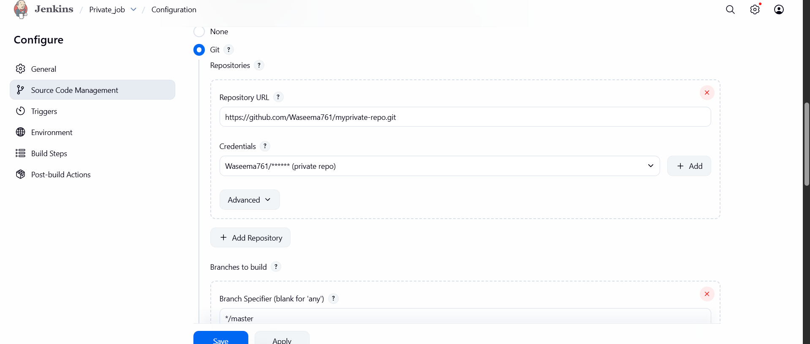
Faced an error while build
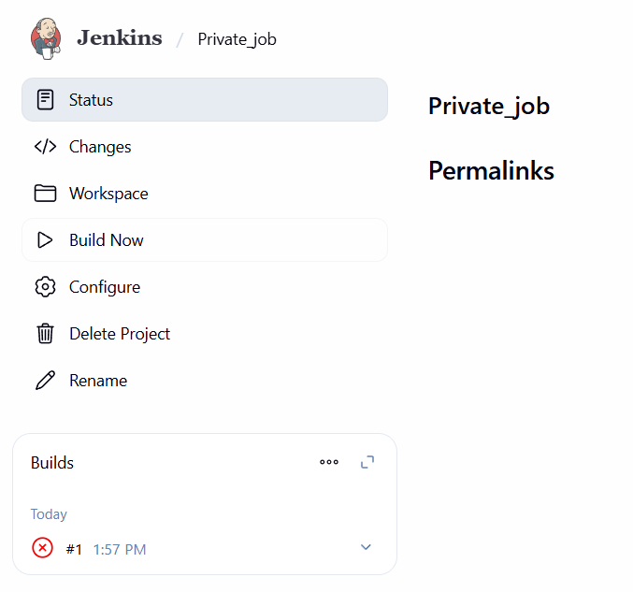
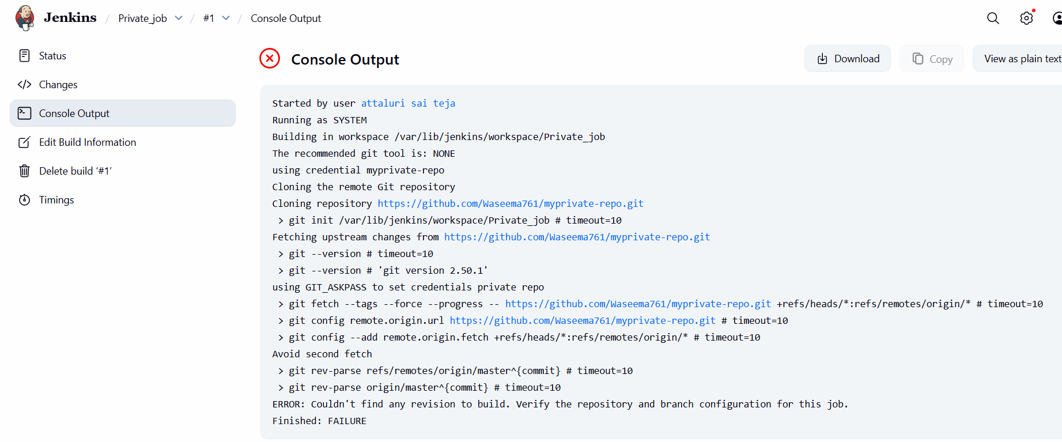
By changing the Master to main branch then issue has been solved
